Digital Literacy: Video

Rationale
Communication is an essential graduate skill. The way we communicate is becoming increasingly complex. Fields such as medicine are already adopting Virtual Reality for training and in practice. We want you to graduate from university being digitally savvy: able to communicate complex science concepts in multiple formats, whether that’s written, verbal or audio-visual
Communicating effectively through digital media is a skill, and all skills need practice. Wherever you end up working, you will have to communicate to different audiences. Perhaps you will be presenting to a group of primary school students, or be part of a government outreach program to get the general population to eat more veggies^{v1.1} or maybe you fancy yourself as a science and technology vlogger?^{v1.2}
In this course, you are going to produce your own video to communicate a topic of your choice from the Human Biology Unit of Study. This is not a film making course, but a journey through effective science communication using an audio-visual format. We are more interested in how well you research and plan your video than in the final product. In the Living Data workshops, you will face new challenges and opportunities to develop your research, critical thinking and digital literacy skills.
Even if you have never made a video before, the series of activities we have designed will guide you through the steps of video production. We prefer you to use your mobile phone to capture the content and we encourage you to use Adobe Spark for putting the video together.
As a way of organising your ideas we will introduce you to narrative structure. This “shape” of narrative is an effective means of communication because it engages your audience intellectually, emotionally and physiologically. Information on its own is not a narrative.

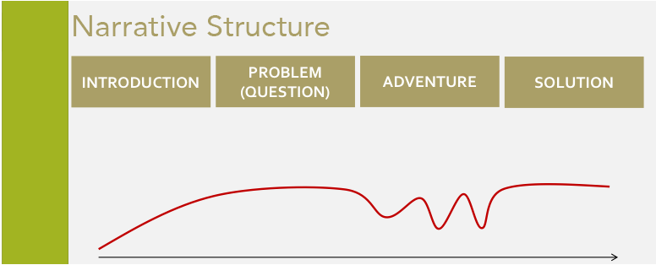
By learning narrative structure, and applying it to a short video, you will have taken your first step to becoming a better communicator and a more digitally literate science graduate.

Overview

You will produce a video based on what you learned in semester. You will select:
- A topic from this course to investigate
- An audience to communicate with
- A style of presentation.
Start thinking about these! You will be formally introduced to these in more detail during Workshop 1 in week 3 (stream A) or week 4 (stream B) and from there, you can select your topic, audience and style.

Topic

When choosing a topic, you may want to start by selecting a system. From there, you can ask a question that relates to specific function or pathological state. You may also want to select a topic that you can relate to or have personal experience with. Don’t be afraid to be creative! You could ask questions such as, Could Humans Ever Breathe Underwater? Perhaps this seems like a bizarre question, but the video presents an interesting discussion of the related science using a narrative structure.

Other examples that may inspire you:
Nervous System
- What is the current understanding of the cause of dementia?
- Why does Parkinson’s disease cause a tremor?
- How does the brain control muscle contractions?
Endocrine
- What happens if my dad doesn’t take metaformin with his meals for his type 2 diabetes?
- Why does my mum need to take insulin injections throught the day?
Respiratory
- What does an asthma puffer do?
Gastric
- Why do I get hungry?
- Why would cheeseburgers make you fat?
Circulatory
- What happens when someone has a heart attack?
- Why do people need to take aspirin after getting a heart attack?
Lymphatic/Immune
- What happens after I graze my skin playing soccer?
- What is a cytokine storm? Why is it so bad? When may it happen?
Musculoskeletal
- Why does lifting weights make me huge?
- Why do bones grow when you grow up?
- Why do astronauts come back from space taller?

Perhaps taking a systems approach will help you ask interesting and unusual questions, with interesting topics to investigate scientifically. After you select a topic, you can think about an audience.

Audience

You are required to select an audience from one of the following:
- Primary School Students
- Peers/First Year University students
- General Public
- Promoting a government agenda

Check the slides at https://goo.gl/Q1JHpT for more detail on these audiences, and links to sample videos. These are discussed in Workshop 1.

Style

You should still use a narrative structure with any of the video styles. Your video should clearly include all four elements of narrative structure: Situation, Complication, Adventure and Resolution.

You will select one of the styles that are available in Adobe Spark, http://spark.adobe.com. They are also listed in the slides from the first workshop. You can use another video editing application if you would like, but we will not help you with technical problems that may arise. We strongly suggest that you use Adobe Spark if you have no experience editing video. Whether you make your video in Adobe Spark or not, you must upload your final video as an .mp4 file and also provide a URL to an online version of your video – which is very easy to create in Adobe Spark. If you use your own software, you can upload it to YouTube or Vimeo to provide us with a URL.

Support outside of class: Lynda.com login

We will be able to help you during class, but if you are having trouble with Adobe Spark, you can access training on Lynda.com. Lynda.com has training for a lot of other software and skills that you may want to learn. To sign in with your Sydney Uni credentials:

Click the Sign In link in the top right.

Click the Sign in with your organization portal link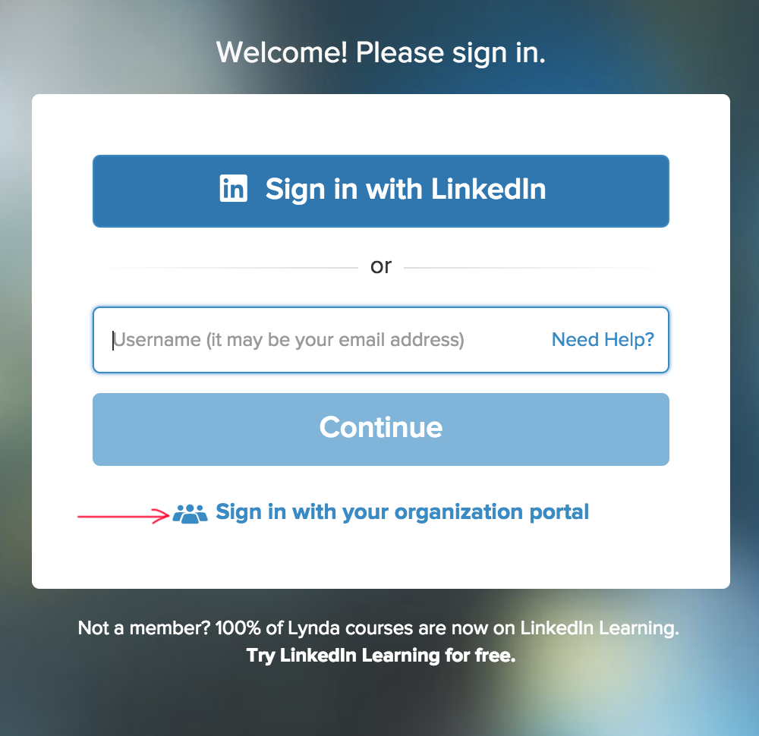

Enter sydney.edu.au in the box on the next page.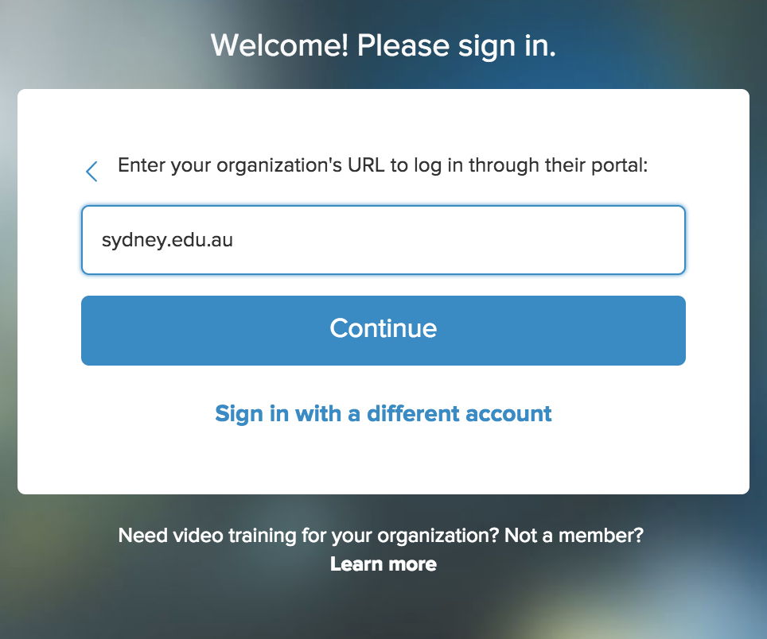

Enter your unikey and password on the Following page. You will be redirected back to Lynda.com

The course you can do is called Learning Adobe Spark with Sandee Cohen. Chapters 1 and 3 have the information that is relevant to our course.

Assessment structure and timeline
This component of the unit contributes 15% towards the final grade and is broken down into 3 tasks to be completed over the semester:
- Draft video plan (1%)
- Peer feedback on draft video plan (4%)
- Final video plan & video (10%)

Assessment timeline
Week | Task
Workshop 1 (in class)  week 3 (stream A)  week 4 (stream B) | Activity to choose a topic from your course, an audience to present to, and a style in which to present.  Introduction to Adobe Spark
Before Workshop 2:  Before week 7 (stream A)  Before week 8 (stream B) | Develop your draft video plan and submit to Canvas before your workshop (1%)
Workshop 2 (in class):  week 7 (stream A)  week 8 (stream B) | Peer feedback on draft video plan (4%)  You will provide and in return receive helpful, structured feedback in this workshop. Please make sure you attend!
Before Workshop 3:  Before week 9 (stream A)  Before week 10 (stream B) | Filming!
Workshop 3 (in class):  week 9 (stream A)  week 10 (stream B) | Peer feedback on draft video  Though this is not an assessment, you will still receive a lot of helpful feedback, it will be the chance to show your tutors the work you have done.
Final Submission Dates  Week 10 (stream A)  Week 11 (stream B) | Submit final video plan and video file (10%).

Draft video plan (1%)
This is the video plan that you will present in class in week 7 (stream A) or week 8 (stream B).
Once you have chosen your topic, audience and style, complete this video plan template and upload the document to Canvas by 11:59 pm on the Sunday night before Workshop 2 in week 7 (stream A) or week 8 (stream B). You must also bring your draft video plan to the workshop as you will present your ideas to a small group of 4-5 peers to receive feedback from each person in your group.

Remember, this is a working document. You will need to make changes after you receive your feedback and upload the final version of your plan along with your video at the end of semester.

Draft video plan marking rubric

Criteria | 0 marks | 0.5 marks | 1 mark | Mark
Submit your draft video plan  You must include your chosen topic, audience and style and some ideas on visuals, content and justifications | No submission | Draft plan submitted but key lacking sufficient detail – no chosen topic or audience or style. | Submitted draft video plan, includes topic, audience, style and includes some ideas for the visuals, content and justification.
 |  |  |  | 1

Peer feedback on draft video plan (4%)

In Workshop 2 running in week 7 (stream a) or week 8 (stream B, you will be divided into small groups of 4-5. You will provide feedback on the draft video plans that are presented to you by your peers within this group. The feedback is to be submitted via a Canvas and is due by 11:59 pm on the Sunday night after Workshop 2. In the few days following, you will receive an electronic version of the feedback from your peers via email.
You will be marked on how you give feedback. For each member of your group, you must:
- Provide their unikey
- Provide their name
- Identify something you liked about their plan
- Explain something you think can be improved
- Identify something that you learned and may apply to your video

Criteria | 0 marks | 1 mark | 2 marks | 3 marks | 4 marks | Mark
Peer to peer feedback on draft video plan in workshop 2.  Provide positive, helpful, constructive feedback to peers and gains insight to your video | No peer to peer feedback provided for any student. | You have provided only one type of feedback (positive or constructive). | You have provided both a positive element and a constructive piece of feedback. | You have provided feedback with both positive and constructive elements and you have described how you have taken something from it/learned something to apply to your own video plan or video. | You have also provided feedback for everyone in your group (up to 3).
 |  |  |  |  |  | 4
Draft video plan: peer feedback marking rubric

Final Video Plan + Video (10%)
For this final task, you will need to upload two files to Canvas by 11:59 pm on the Sunday at the end of week 10 (stream A) or week 11 (Stream B).
- A pdf containing:
  - Your final video plan (4 marks). Address how you fit your video into the narrative structure and complete every column for each row of content.
  - On paragraph at the end of the plan (max 300 words) providing a justification around your chosen audience, topic and style (1 mark)
  - URL link to your video, in case there are issues with the video upload to Canvas
- Your video in .mp4 format (5 marks).

Final video plan & justification marking rubric

Criteria | 0 marks | 1 mark | 1.5- 2 marks | 2.5 - 3 marks | 3.5 - 4 marks | Mark
Final video plan  Identify the topic, audience and style of video you will create.  Provide a detailed breakdown of the content, visual and reason (justification) for your choices.  Outline how your video follows a narrative structure.  4 marks | No plan submitted. | An unsatisfactory plan which is missing key details.  Missing information on topic/audience/style chosen and there is a lack of information on visuals used, planned video content and justification of content.  Does not demonstrate a clear structure. There is no evidence of researching the chosen topic. | A reasonable video plan but missing some information.  Either details on the chosen topic/audience/style or insufficient detail on the planned content, visuals and justification.  There is no clear structure to the plan and little evidence of researching the chosen topic. | A good, complete video plan.  Shows planning of the content and visuals used, and why.  The plan follows a narrative structure and has been carefully planned. Topic has been researched. | Excellent video plan.  Clearly demonstrates a narrative which is easy to follow and very well thought out.  The plan demonstrates critical thinking about the topic and draws on multiple evidence sources to construct content for the video. The topic and audience choice have clearly been researched. | /4
Justification of chosen topic/audience and style  (maximum 300 words to describe why you chose the topic, audience and style)  1 mark | No justification submitted. | A justification has been submitted of the chosen topic, audience and style. |  |  |  | /1

Video marking rubric
Criteria | 0 marks | 1 mark | 1.5- 2 marks | 2.5 - 3 marks | 3.5 - 4 marks | 4.5 - 5 marks | Mark
Final video  Communicate appropriately to chosen audience.  Content is appropriate for audience and chosen topic.  Video follows a narrative structure.  5 marks | No video. | A video is submitted but it is unsatisfactory.  The content is not appropriate for the intended audience.  Content does not represent the chosen topic and lacks coherence. Little evidence of any research beyond lectures. The video is poorly organised and there is no clear structure or narrative.  Very little effort made overall. | Video is satisfactory.  Some of the content is appropriate for the intended audience but there are some mistakes.  The chosen content reasonably represents the topic but is not well organised into a coherent narrative structure. Some evidence of research around topic.  Some effort has been made. | A good video is submitted.  Most of the content is audience appropriate.  Student uses good content to describe the chosen topic. Evidence of further research conducted on topic. The video follows a clear narrative structure.  A good effort overall. | Very good video.  The content is appropriate for the intended audience.  Organised structure, which demonstrates a clear narrative.  Student explains chosen topic in relative terms, explaining complex concepts well for the chosen audience. Good use of external sources of evidence and visuals to communicate effectively.  Really good effort overall. | Exceptional video.  The content is appropriate for the intended audience.  Very well organised structure, which demonstrates a clear narrative. A critical understanding of the topic is demonstrated, including own point of view. Excellent use of external sources of evidence and visuals to communicate effectively.  The video is of a very high quality. | /5
 |  |  | Total Mark (all components) |  |  |  | /10

