Hints, tips and editing apps

Make sure you:
- Have sufficient data storage space on your device
- Have at least one video editing app on your phone and computer
- Clean you lens
- Shoot in the right orientation
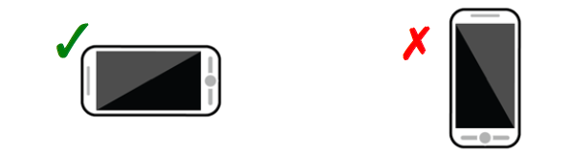

- Be careful not to cover the microphone or lens with your fingers when filming.
- Don’t have a tripod? Don’t worry- you can be your own steady cam! Use both hands, hold your arms close to your body and rest your elbows on a table or your hips for a shake free shot.
- Don’t use the digital zoom within the video app- get closer to your subject.
- Double tap the screen to see the full frame.
- Tap the screen to focus (on some devices you can change the focal point whilst filming too)
- Change angles to keep the shots interesting
- If you have two smartphones- use one for video and one for audio:
- Use the voice memo/voice recording app on one phone and place it directly above/near the subject/s
- Clap at the start of the scene to help you match up the audio and footage when editing
- Be aware of the noise at your shoot location:
- External sounds like birds, air conditioners, lawn mowers can have a detrimental impact on your footage audio
- Wind can also be an issue- shoot a sample and see if the background noise is an issue
- If you’re shooting in a noisy location, consider your alternative audio options- for example, music, voiceover, narration.
- Make sure your subject is well lit:
- Use the sun when you can
- Position your camera near a large window or light source so your camera is capturing the light on the subject
- Avoid shooting your subject with lots of light behind them (unless you are going for a silhouette effect)
- Back-up your footage regularly to a computer if possible.
- Make sure at least two team members have a copy of the final file.

Video editing apps and software

Best video editing software for Android
http://www.techradar.com/news/the-best-free-video-editing-app-for-android
Source:TechRadar.com – December 2017

6 best free video editing apps for iPhone and iPad
http://www.makeuseof.com/tag/best-free-video-editing-apps-ios/
Source: Makeuseof.com- December 2017

6 best free video editors
Lifewire.com – December 2017
https://www.lifewire.com/best-free-video-editing-software-programs-4128924

Music
Many video editing apps/software give users access to some stock, copyright free music.

The advice provided above is general in nature and designed to assist students in getting started with their videos. It is not intended to be exhaustive or prescriptive.
Please observe standard copyright laws when using copyright protected images and/or sounds in your videos.

