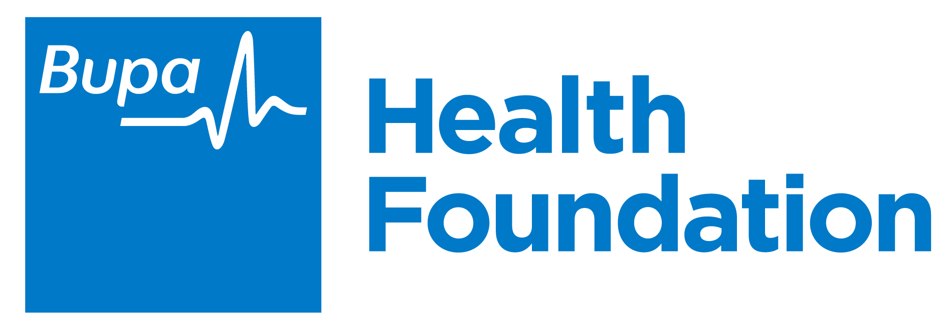

Best Care, First Time

Optimising youth mental health services using digital technologies

Authors: Frank Iorfino, Ante Prodan, Sarah Piper, Jo-An Occhipinti, Annette Schmiede, Haley LaMonica, Tracey Davenport, Elizabeth Scott & Ian Hickie

June 2021

Contents

Acknowledgement of Country 2
About this report 3
Key messages 4
Youth mental health care in Australia 5
The complexity of youth mental health 6
A technology-enabled ‘circle of care’ 7
Key components of the circle of care 7
The Brain and Mind Centre Youth Model of Care 8
Technology-enabled service delivery 8
What we are doing 9
Dynamic Simulation Modelling 9
Health service implementation 10
A key insight from our initial implementation work – cooperation is crucial. 10
Creating a smart health service infrastructure 10
Preliminary insights and implications 11
Concluding remarks 17
References 18
Acknowledgements 20
Appendix A – Codesign work 21
Appendix B - Model description 22
Sample characteristics 22
Appendix C – Implementation work 30

Acknowledgement of Country
We would like to acknowledge the Gadigal people of the Eora Nation who are the traditional owners of the land on which we work, and this report was produced. We pay our respects to Elders past, present, and emerging.

About this report
The Youth Mental Health and Technology team at the Brain and Mind Centre aims to change the way in which clinical care is delivered to young people with emerging mental health disorders. To do this, we are utilising sophisticated digital technology and systems modelling to shift the way that services deliver care, to modernise and connect the previously disconnected mental health system in Australia, allowing young people to seamlessly move through the system and receive the best care as required.

This work is made possible by the Bupa Health Foundation, one of Australia’s leading charitable organisations committed to addressing the health needs of the Australian community to help people live longer, healthier, happier lives. The investment provided by the Bupa Health Foundation, and their ongoing support of and collaboration with the research team, speaks to the value, and progressive nature of this work.

This report provides on overview of the current research project (‘Can digitally-supported care pathways deliver better care for young people with emerging mood or psychotic disorders?’), and importantly, aims to promote the potential of this work to the broader mental health community, including policy-makers, funders, service managers, and clinicians. By publicly advocating for the adoption of digital technologies, and the application of systems modelling approaches, it is possible to bring the exponential benefits of these under-utilised methods to the forefront of mental health care, and mental health care research, in Australia. This highly translational work is not limited to sitting within a circle of academic papers, but can affect change in real-world mental health care settings almost immediately – through the adoption of digital technologies, which can enable a more accessible, effective and connected mental health system, directly benefiting the young people who need to use it.

Key messages
- Care coordination is integral to addressing difficulties in accessing and navigating youth mental health care. We need seamless communication and coordination within and between mental health services, that will guide the young person to the care that they need, and reduce instances of those receiving inappropriate care, or no care at all. Yet, it is often unclear how this can be achieved in a complex mental health system.

- We recommend creating a technology-enabled ‘circle of care’ – which aims to facilitate continuous and streamlined transitions for young people accessing primary, secondary, and hospital-based care, ensuring that the young person can easily access the best care, first time. This can be achieved through two fundamental shifts in current service provisions;
  - a model of care which puts the person at the centre of their care; and
  - a technology infrastructure that facilitates the circle of care

- Our modelling suggests that when compared to business as usual, implementing a technology-enabled ‘circle of care’ to bridge the gap between service providers:

- Young people received the right care plan in 21 days, which was four times faster than business as usual (80 days).

- 49% of young people recovered over the course of care, which is a 32% increase from business as usual (37%).

- Young people waited 60 days for psychology services, which was 90 days faster than BAU (150 days).

- 42% of young people disengaged or did not have their needs met over the course of care. This is a 30% reduction compared to BAU scenario (60%).

- These results emerge from changes to the model of care and the use of technology to improve service pathways within and between services. The capacity of each service has not been changed and are identical to business as usual. Further gains are likely to be made if capacity is expanded also, however this work highlights the potential gains that could be realised by improving the way services operate.

- To achieve these improved outcomes, we recommend the following changes to the way service operate and use technology:

- Standardised entry pathways that use online multidimensional assessment and triage.
- A personalised model of care to allocate care based on clinical stage and need.
- Highly skilled clinicians are utilised early in the intake and care planning.
- Automated progress reviews and real-time monitoring.
- Reduced duplication and increased interoperability of information systems.

- This work also demonstrates the benefits of creating a smart health service infrastructure which embeds dynamic simulation modelling and health service implementation research into services to rapidly test the likely impacts of alternative strategies for resource capacity, allocation, scheduling, and other measures to improve operational efficiency and clinical outcomes.

Youth mental health care in Australia
There has been significant effort and investment by national and state governments of Australia to improve outcomes for people affected by mental ill-health. And there are many affected – almost half of all Australians will experience mental ill-health in their lifetime (Australian Department of Health, 2017). From the institution of the National Mental Health Strategy (1992) to the present day, major reforms and initiatives have been implemented: a shift from a reliance on psychiatric hospitals to community-based services, the expansion of the Medicare Benefits Schedule to include access to mental health professionals, the promotion of mental health awareness and de-stigmatisation, and a focus on youth mental health and preventative measures (Australian Institute of Health and Welfare, 2021).

Despite these efforts, mental health outcomes in this country remain poor, particularly for young people (Lawrence et al., 2016). Suicide still remains the leading cause of death for 15 to 24 year olds (Australian Institute of Health and Welfare, 2020) and just under one quarter of young Australians (aged 15-19 years) meet the criteria for a probable serious mental illness (Mission Australia, 2017), an alarming indication of future health outcomes if not addressed. It is evident that the Australian mental health system is facing challenges which impact its capacity to deliver quality care – and young Australians are suffering.

Whilst initiatives such as headspace have created a popular ‘front door’ for young people to access care, there has been a failure to build the ‘back end of the system’, referring to the availability and accessibility of more specialised and acute forms of mental health care ("Pat McGorry on the 'missing middle' of funding for mental health", ABC Radio, 2021). With a ‘front door’ to care, extensive appointment wait times and no supported pathway to the appropriate care, many young people are at risk of joining the ‘missing middle’ – a term used to describe individuals whose needs are not met by the current mental health system. These individuals are often too ill for primary care services, but not ill enough to access more specialised, state-based services (Orygen, April, 2019). If a help-seeking young person does meet the criteria for a more specialised service, there is still a risk that they will ‘fall between the gaps’ when transitioning across mental health services, as health professionals and services tend to operate in isolation, with a lack of communication and coordination between them (Groom, 2003; National Mental Health Commission, 2014).

This reflects a fundamental mismatch between the nature of mental disorders among young people (i.e. dynamic and multifaceted) and the way the mental health system operates to treat them (i.e. rigid and siloed). Unfortunately, the mental health system in Australia is not set up in a way that recognises this dynamicity and complexity of youth mental health. Instead we have a siloed and rigid system that tends to deliver ‘episodic’ rather than ‘continuous’ care, whereby young people are left to navigate the complexities of the health system to access the appropriate services (Adair et al., 2005; Brophy, Hodges, Halloran, Grigg, & Swift, 2014; National Mental Health Commission, 2014). This leaves individuals at risk of receiving no care at all, or an inappropriate level of care whereby many tend to leave care having not fully recovered nor their needs completely addressed, which can lead to worse outcomes for young
people at higher costs to the health system (Shane Cross, Hermens, & Hickie, 2016; Shane Cross et al., 2014).

As service inefficiencies, redundant practices, and poor information flows within the current system have come to light, and as demand for mental health care continues to rise, services find themselves under increased pressure and under-resourced to address these challenges and improve the quality of care young people receive (Carlo, Barnett, & Unützer, 2020). Thus, it is widely recognised that there is a need to transform the way the mental health system coordinates and delivers care. Attempts to address these issues through the adoption of digital mental health care have been fast-tracked due to the COVID-19 pandemic (Ben-Zeev, 2020), however, there is a lack of clarity about the way forward, and how to get there.

The complexity of youth mental health

A lived experience perspective

Alex’s story
After months of slowly choosing not to leave the house each day and creating ailments to excuse me from school, I finally broke down and admitted I needed help one night on my front porch. I initially contacted headspace and was so happy to just talk freely about all of my worries and fears. I was immediately diagnosed with general anxiety disorder and was handed a pamphlet - I matched every symptom they had listed. Despite choosing to get therapy, I still could not bring myself to leave my house so I started losing friendships, falling behind on assignments and every conversation with my parents became a fight. After three months I had completely lost hope that I would ever function normally again and developed depression.

Harming became a coping mechanism. Scratching scabs onto my wrists became razors on my thighs. I denied that I’d done anything at all until my pants soaked through and I couldn’t hide the medical supplies I was using. My parents didn’t understand. They were disappointed, horrified and confused, the term ‘self-mutilation’ was used liberally… and made me disgusted [in] myself.

After a change to a psychiatrist and admitting to suicidal ideation, I was instantly put on medication. In my two years with this psychiatrist, I tried 5 antidepressants with awful side effects. After another change of counsellors and much experimentation, there came a diagnosis of bipolar disorder type 2. I was so relieved, there was finally a name for what I was experiencing and a more specific way of treating it. Stability seemed like it was on the horizon.

Ten months later, I’m struggling through the HSC, have a part-time job, am on a routine cocktail of antidepressant, mood stabiliser and ADHD treatment and it’s only just hit me that my condition is chronic and lifelong. I finally caught up on life and looked to the future only to find it’s scary and will probably have many challenges with mental health. I may never be ‘stable’ and that’s my current struggle.

Jess’s story
I patiently waited four long months to see a Psychiatrist and during my first session I immediately felt like I was being judged and that I could have done something along the way to prevent my mental health decline from happening. I was so confused; I did not understand what had happened and why. When I asked my Psychiatrist if there were any resources, I could read to better understand what had happened to me, her answer was “mmmm, not really”, immediately taken aback by this I asked if she could explain to me why stress had essentially been the start of my deterioration and why I wouldn’t have experienced something else, like a terrible flu or a strep infection, or shingles due to being run down and overworked. I wanted a better understanding, not just a script and sent on my way. The answer I got was “well people with your personality style are prone to things like this”. Her words made me feel like it was my fault, that it was due to my personality, and that, I if I had a different personality, I wouldn’t be there seeking help. I wanted to go back and do my life all over again, with a different personality... I was told “perhaps you need to see a psychologist”. I was so vulnerable, emotional and all over the place, and those words were so dismissive, it was like I was asking questions that were beneath her as a Psychiatrist. I had two sessions with this Doctor, paid almost $1000 and left each time with the most terrible rumination about myself. No one should ever have to feel like their mental-ill health is their own fault.

A technology-enabled ‘circle of care’
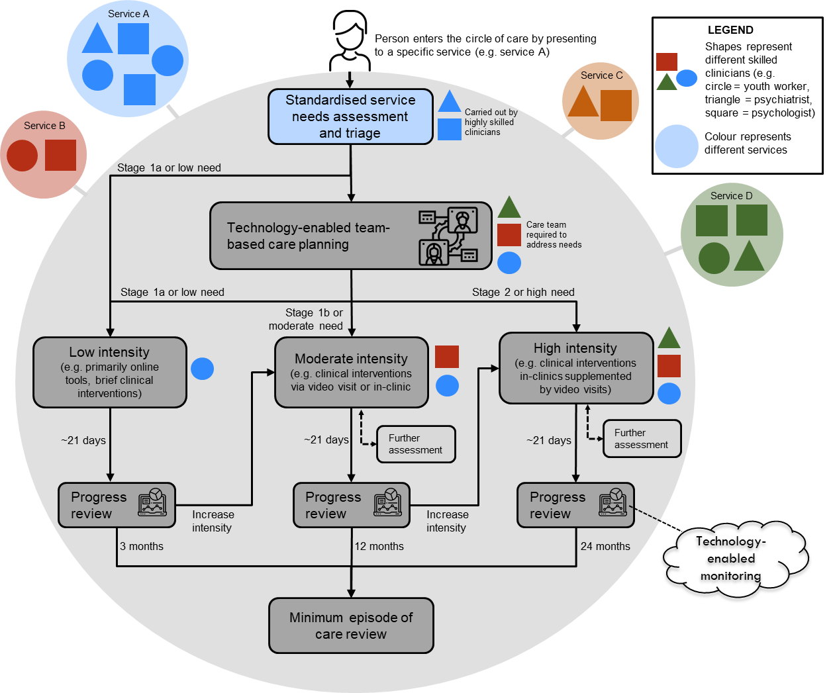
In response to these fundamental issues, a key recommendation of the National Review of Mental Health Programmes and Services (National Mental Health Commission, 2014) was to redesign the mental health system to focus on the individual, their families, and their supportive others, rather than on the service provider. There is a need to create a ‘circle of care’ around the young person - that is, continuous and streamlined transitions as the young person travels across primary, secondary, and hospital-based care, ensuring that the young person can easily access the best care, first time. Care coordination is integral to addressing difficulties in accessing and navigating mental health care (Brophy et al., 2014). We need seamless communication and coordination within and between mental health services, that will guide the young person to the care that they need, and reduce instances of those receiving inappropriate care, or no care at all.
Figure 1. Shared and interoperable technologies improve standardisation and communication across services to create a ‘circle of care’ (Davenport et al., 2020).

Key components of the circle of care
- No wrong door (or waitlist) - Each service has a standardised care entry pathway that uses rapid assessment and triage to help determine which part of the system a person is best suited for.

- Personalised and multidisciplinary care decisions - Care decisions are driven by an individual’s needs by breaking down service boundaries to focus on getting the right team involved, identifying the type and length of care required, the mode(s) of delivery, and need for further assessment.

- Responsive care (‘measurement-based’) - Routine outcome monitoring means that changing needs will be met with changes to the care provided (e.g. increase intensity or changes to the care team). Outcome monitoring can occur at a micro (daily or weekly) or macro (monthly or yearly progress reviews) level.

To achieve the circle of care two fundamental shifts in current service provisions are required:
1. a model of care which puts the person at the centre of their care; and
2. a technology infrastructure that facilitates the circle of care

The Brain and Mind Centre Youth Model of Care
The Brain and Mind Centre (BMC) Youth Model of Care; a ‘person centred’ model of care that shifts focus from the service provider and traditional diagnostic classification systems to the consumer and their unique needs, provides a guide to up-skill clinicians and deliver this care. The BMC Youth Model recognises that early onset mental ill health is a predictor of severe and recurrent mental disorders later in life (Paus, Keshavan, & Giedd, 2008), that comorbidity and subthreshold symptoms are common and must be accounted for in treatment approach, and aims to prevent progression to more advanced stages of illness (I. B. Hickie et al., 2013; Scott et al., 2013; Shane P. M. Cross et al., 2014). The BMC Youth Model utilises multidimensional assessment and treatment, a wider list of personalised treatment options, the promotion of consumer participation in their own mental health care, the provision of earlier and more effective clinical interventions, health professional education and training (Dohnt & Dowling, 2020), and critically, health data tracking enabled by new and emerging health information technologies (HITs), with the aim of delivering the best care, first time (I. B. Hickie et al., 2013; McGorry et al., 2007).

Technology-enabled service delivery
Health information technologies (e.g. internet-based platforms, apps and e-tools) provide a promising way to address the practical barriers related to individuals navigating the mental health care system. The University of Sydney’s Brain and Mind Centre has been working to develop a digital platform (e.g. the InnoWell Platform) that can enable the practise of the BMC Youth Model across different service providers. The InnoWell Platform is a new and innovative internet-based system that is designed to help individuals manage their health and wellbeing across the lifespan. It does this by collecting, tracking, and reporting health information back to the individual and the health professional to encourage ongoing, collaborative care partnerships (Davenport et al., 2019). It is listed on the Australian Register of Therapeutic Goods (software as a medical device, class 1, ARTG ID 315030). Though we reference the InnoWell Platform as an exemplar HIT, it is important to note that the BMC Youth Model can be adopted via any HIT so long as its design has been guided by similar clinical and scientific concepts to provide highly personalised and measurement-based care.

Table 1. The BMC Youth Model and technology components to enable the ‘circle of care’.
Component | How will it enable the ‘circle of care’?
Standardised and ongoing multidimensional online assessment | Provides consistent and comprehensive assessment of a young person’s needs and prevents the need to ‘re-tell their story’ to multiple services.
Reliable triage to facilitate personalised care pathways (matching level of care to individual) | Efficient triage processes improve appointment attendance rates (Sherman, Barnum, Buhman-Wiggs, & Nyberg, 2008) and reduce the negative effect of wait times, including loss of motivation and lowered expectation of improving (Westin, Barksdale, & Stephan, 2014). Furthermore, accurate triage matches appropriate level of care to the individual’s needs and manages demand by reserving more intense treatment for clients with greater need (Fletcher et al., 2019).
Personalised care plans for both individuals and health professional (identifying care team) | Care coordination initiatives (e.g.., The Partners in Recovery model) utilises a ‘support facilitator’ or technology capabilities to identify and coordinate a personalised treatment plan based on an individual’s needs. This allows services and the individual to monitor response to treatment and guide shared decision-making. team. Such models of care reduce the rate of unmet needs (Isaacs, Beauchamp, Sutton, & Kocaali, 2019).
Real-time data tracking | Clinicians that are notified of a clients’ deterioration are more likely to intervene and improve outcomes by adjusting the type and intensity of treatment (Lambert, Harmon, Slade, Whipple, & Hawkins, 2005).
Video-visit functionality | Provides cost-effective assessment and monitoring of client profiles with poor access to in-person health care. Clinicians can provide faster and more accurate support than tele-care as video-visits enable the assessment of visual cues.
Shared and interoperable technology for assessment data and care plans | Electronic health records of patients can be securely and efficiently shared between various services to increase access of patient data and facilitate shared decision-making (Jones & Ku, 2015).

What we are doing
We have employed an innovative approach which utilises both dynamic simulation modelling (DSM) and health service implementation research to evaluate how, and if, technologies can facilitate some critical transformations within the youth mental health system to improve access and coordination (a ‘circle of care’) between services and improve mental health outcomes for young people. A group of local services representing a range of levels of care (e.g. primary, hospital, etc.), located in a similar geographical region (inner Sydney, Australia), were selected to provide an initial ‘circle of care’ setting in which individuals would naturalistically be referred between. Participating services included:
- Commonwealth-funded initiatives (Primary Health Network-funded headspace centres)
- Private Hospital Provider (St Vincent’s Private Hospital - USpace)
- Private specialist practice consortia (Mind Plasticity)

Dynamic Simulation Modelling
By applying an innovative DSM approach imported from engineering and previously applied to map complex health system patient flows, we have created a simulation model of a new locally focused ‘circle of care’. We have used a hybrid systems modelling approach that combines discrete-event simulation and agent-based modelling. Agent-based modelling is a computational approach whereby agents with a specified set of individual-level characteristics can interact with their environment (i.e. health services) to shape individual health outcomes. Discrete event simulation captures the resource and operational aspects of the services and service pathways with which individuals interact and receive care. We have collected qualitative and quantitative data from stakeholders regarding various elements of services, population characteristics, and service efficiency metrics (see table 1, Appendix A). This data has been used to create an initial simulation model of the local service pathways, and the local population of young people attending these services.
Scenario 1:  Business as usual | Scenario 2:  Basic implementation | Scenario 3:  Ideal implementation  (‘circle of care’)
The service system is based on existing service pathways within and between participating services. This largely reflects what occurred pre-2020. | The digital technology is implemented into each participating service. However, there is limited integration with existing systems (poor interoperability) and limited change to the underlying model of care. | The digital technology is implemented into each participating service in a way that is highly interoperable, and the underlying model of care is adapted to facilitate more personalised and measurement-based care.

The aim of the simulation model is to examine the effect of technology-enabled ‘circle of care’ on youth mental health outcomes and health service efficiencies. At the start of the simulation a population of 15,000 young people (‘agents’) aged between 12 – 25 is created each with distinct demographic and clinical characteristics. The simulation is run for 4 years (+1 year lead in time), and during this time agents will seek help and engage with one of the participating services. When engaging with these services they are allocated to a pathway of care to receive treatment (e.g. intake to care planning to treatment). The allocation of treatment plans and the care pathway an agent follows are dependent on the service processes and use of technology, which vary under different scenarios (Table 2). Over time, agents will present for treatment according to their treatment plan and the effectiveness of treatment on outcomes is dependent on whether the care plan is ‘right’ for that agent. Agents can disengage from services due to waiting too long or dissatisfaction with treatment, or they can recover over the course of care. A detailed description of the model structure and assumptions can be found in Appendix B.

Table 2. Simulation model scenarios

Health service implementation
This implementation work focuses on ensuring that both components of the ‘circle of care’ (BMC youth model of care and technology) are embedded with services, to improve care coordination and continuity within and between the services. The InnoWell Platform was configured using the data collected from the stakeholder workshops (Table 1, Appendix A), to ensure that the clinical content was appropriate to the adopting service. The Platform was then implemented into three participating services: headspace Camperdown, Mind Plasticity, and USpace outpatient clinic (St Vincent’s Private Hospital), to be utilised for at least 12 months within the service. The impact of this implementation will be evaluated over 12 months (details in Appendix C).

A key insight from our initial implementation work – cooperation is crucial.
There remains a crucial element in seeing tangible change to the mental health system through the adoption of technology– the cooperation and participation of mental health services across Australia. The risk of continuing with the status quo, that is, services that are disconnected from each other, and operating within the confines of an inefficient and burdensome system structure, is now greater than the risk of implementing change. The technology-enabled ‘circle of care’ that is needed to support and guide a young person through our mental health system, to ensure that they are receiving the best care, first time, cannot be built without the participation of mental health services and their funding and administrative bodies. The greater the participation, the more expansive the circle becomes. The willingness of Mind Plasticity, headspace Camperdown (Central and Eastern Sydney Primary Health Network), and Uspace at St Vincent’s Private Hospital to participate in this work, showcases these services’ inclination to look to the future, and affect change from an individual service level. Next, there must be a willingness from health organisations to engage in this change at a higher level (e.g., State based Local Health Districts, national organisations), and to lead and drive change also.

Creating a smart health service infrastructure
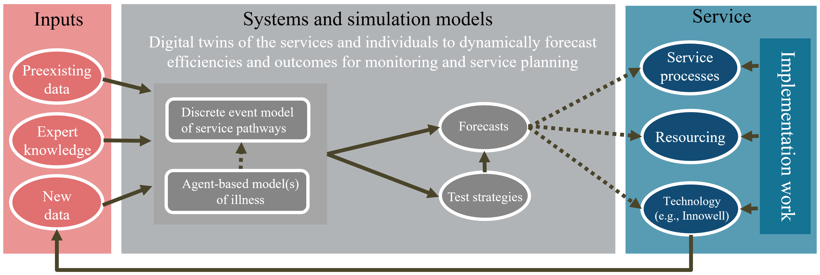
The combination of the DSM and health service implementation work aims to create a smart health service infrastructure to guide service planning and improve pathways to care based on real-time data about the local service population needs, staff resourcing, processes, throughput statistics etc (Figure 2). The hybrid agent-based and discrete event simulation model acts as a digital twin of service environment and their service populations to be able to dynamically forecast service performance and clinical outcomes based on pre-existing and new (ongoing) data collection. This infrastructure can then be used to test the likely impacts of alternative strategies for resource capacity, allocation, scheduling, and other measures to improve operational efficiency based on the changing needs of a given population over time. Expert knowledge and other secondary data sources can continuously be used to recalibrate, improve, and refine the DSM so that these models reflect the real world and have greater utility for informing the best strategies and processes for improving service efficiency and performance.

Figure 2. Establishing a sustainable monitoring framework that utilises DSM and health service implementation practices to iteratively improve service efficiency and performance.

Preliminary insights and implications
The following results demonstrate the potential impact that creating the technology-enabled ‘circle of care’ for young people presenting for mental health care could have on service efficiencies and clinical outcomes. In the current report we focus primarily on entry into care, specifically on how digital support care pathways can be used to direct young people to the right level of care. Results are presented in a way that shows the comparative impacts between different scenarios against a baseline of business as usual (BAU). These are the preliminary results from multiple (50) runs of the model with (default) parameter values. As the model is essentially stochastic, each run results in a different output. These results are subject to more rigorous validation and sensitivity analyses.

Insight 1: More young people get to the right type of care, faster.

Young people in the technology-enabled ‘circle of care’ received the right care plan in ~21 days, which is about 4 times faster than BAU scenario (80 days), and basic scenario (~90 days).

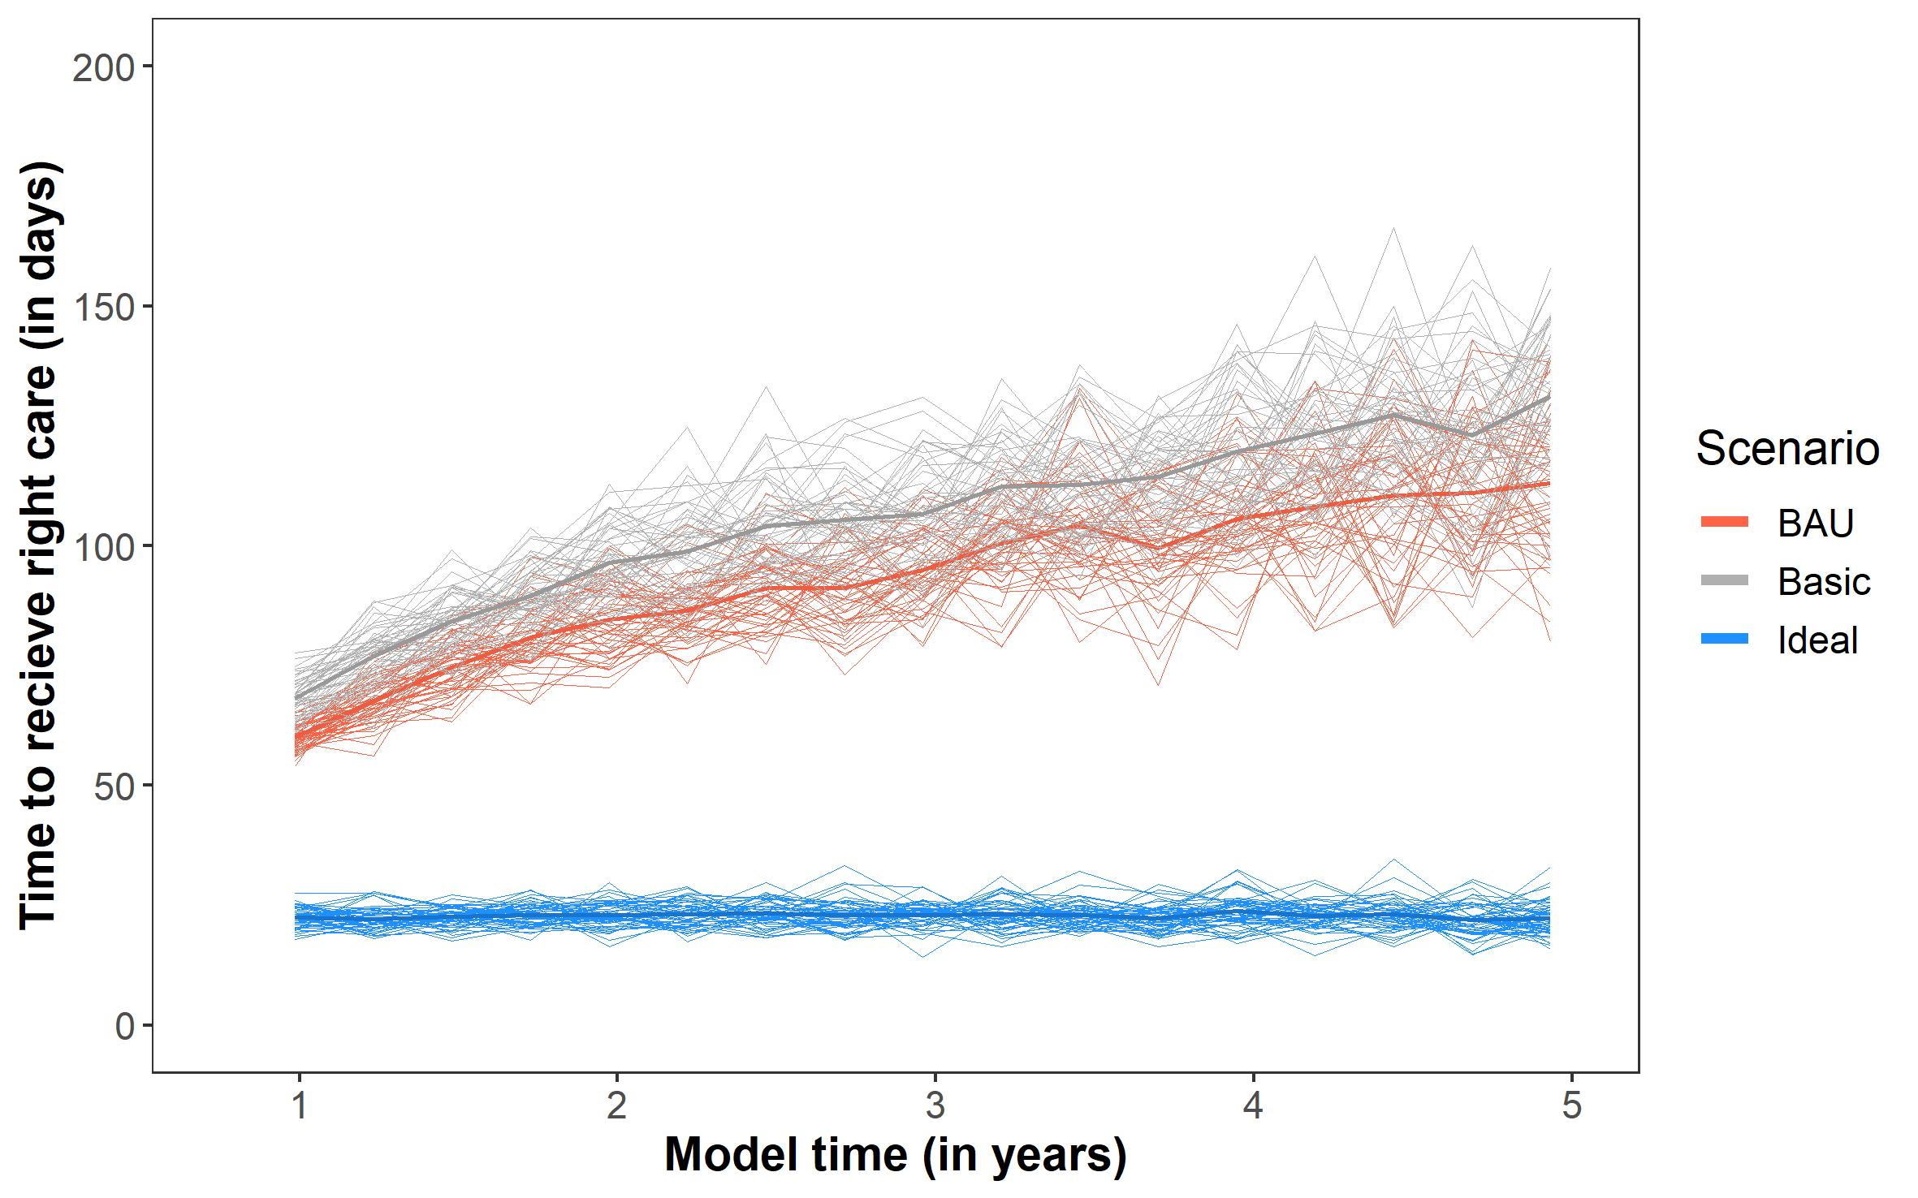
Figure 3. Data presented is the rolling average number of days to receive the right care plan for all people who were allocated the right care plan in the previous quarter.

The use of standardised digital pathways into care leads to significant reductions in the time it takes to complete intake and subsequently receive a care plan. Receiving a care plan does not necessarily mean it is ‘right’ for the individual. Service capacity constraints for psychology or other health professionals means that there are often delays before receiving the right type of treatment. The data presented here is a rolling average for all people still engaged with care (does not include those disengaged or recovered), but you can see that over time, under ideal conditions, digitally supported care pathways lead to consistently faster times for matching the care plan to an individual’s needs (Figure 3).

The ideal scenario offers standardised entry points to the ‘circle of care’ whereby a young person’s needs are assessed online and triage algorithms are used to identify ‘very mild’ and ‘very severe’ individuals and fast track their entry to the relevant care. For those with ‘mild’, ‘moderate’, or ‘severe’ clinical needs, they progress to care planning which is carried out regularly by a senior clinician who directs the young person to the right level of care in the system. The BAU and basic scenarios rely too heavily on face-to-face contacts for assessment which lead to bottlenecks and has no systematic way of triaging cases based on level of clinical needs. The BAU and basic conditions also refer people away at entry if they do not meet criteria for the service. This means that young people are referred to another service and will have to re-present, which lengthens the time from help seeking to receiving a care plan.

The efficiencies gained under ideal conditions are despite seeing approximately 3922 more young people, a ~45% increase from BAU. The use of senior clinical staff for care planning, more regular review and monitoring of an individual’s needs and the care plan means that the chances of being directed to the right type of care, faster, are increased. See appendix B for model logic about ‘right’ care.

Insight 2: A higher proportion of young people recover over the course of care and they recover more quickly.

About 49% of young people in the technology-enabled ‘circle of care’ recovered over the course of care. This is a 32% increase compared to BAU scenario (37% recovered), and basic scenario (37% recovered).

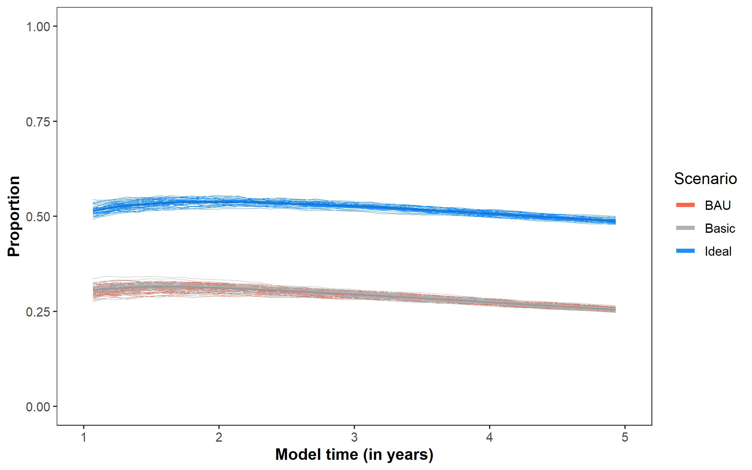
Figure 4. Overall proportion of people who recover during their engagement with services.

The increased proportion and faster rate recovering during the ideal scenario, compared the BAU and basic scenarios can be attributed to the combination of increased service efficiencies (insight 1), the systematic use of personalised and measurement-based care. With regards to treatment plans, the only difference between each of the scenarios is that the treatment frequency and review is personalised to the agent in the ideal scenario. Treatment frequency and progress reviews are conditional on stage and need (see BMC youth model figure 8, Appendix B). This reflects the use of technology for personalised and measurement-based care which involves reliably identify suitable intervention targets for an individual (‘personalised’) and; monitoring outcomes over time (‘measurement-based’)(Ian B Hickie et al., 2019). Personalised and measurement-based care is a core component of the chronic care model and supports better-informed clinical decisions.

Despite good evidence for its effectiveness and its customary use in medical disease management (Shimokawa, Lambert, & Smart, 2010; Tam & Ronan, 2017), it remains largely absent from current youth mental health care. The results here demonstrate the potential benefits for not only service efficiencies but clinical outcomes, if personalised and measurement-based care can be effectively implemented into services, with the support of technologies. Furthermore, the increased rate of recovery is also likely to be the result of a positive feedback loop between recovery and service efficiency (as more people recover, the number of people being allocated to the right care plan increases which increases the probability of recovery). This highlights how we may be able to identify critical points in the existing system which may deliver compounding benefits via such feedback loops.

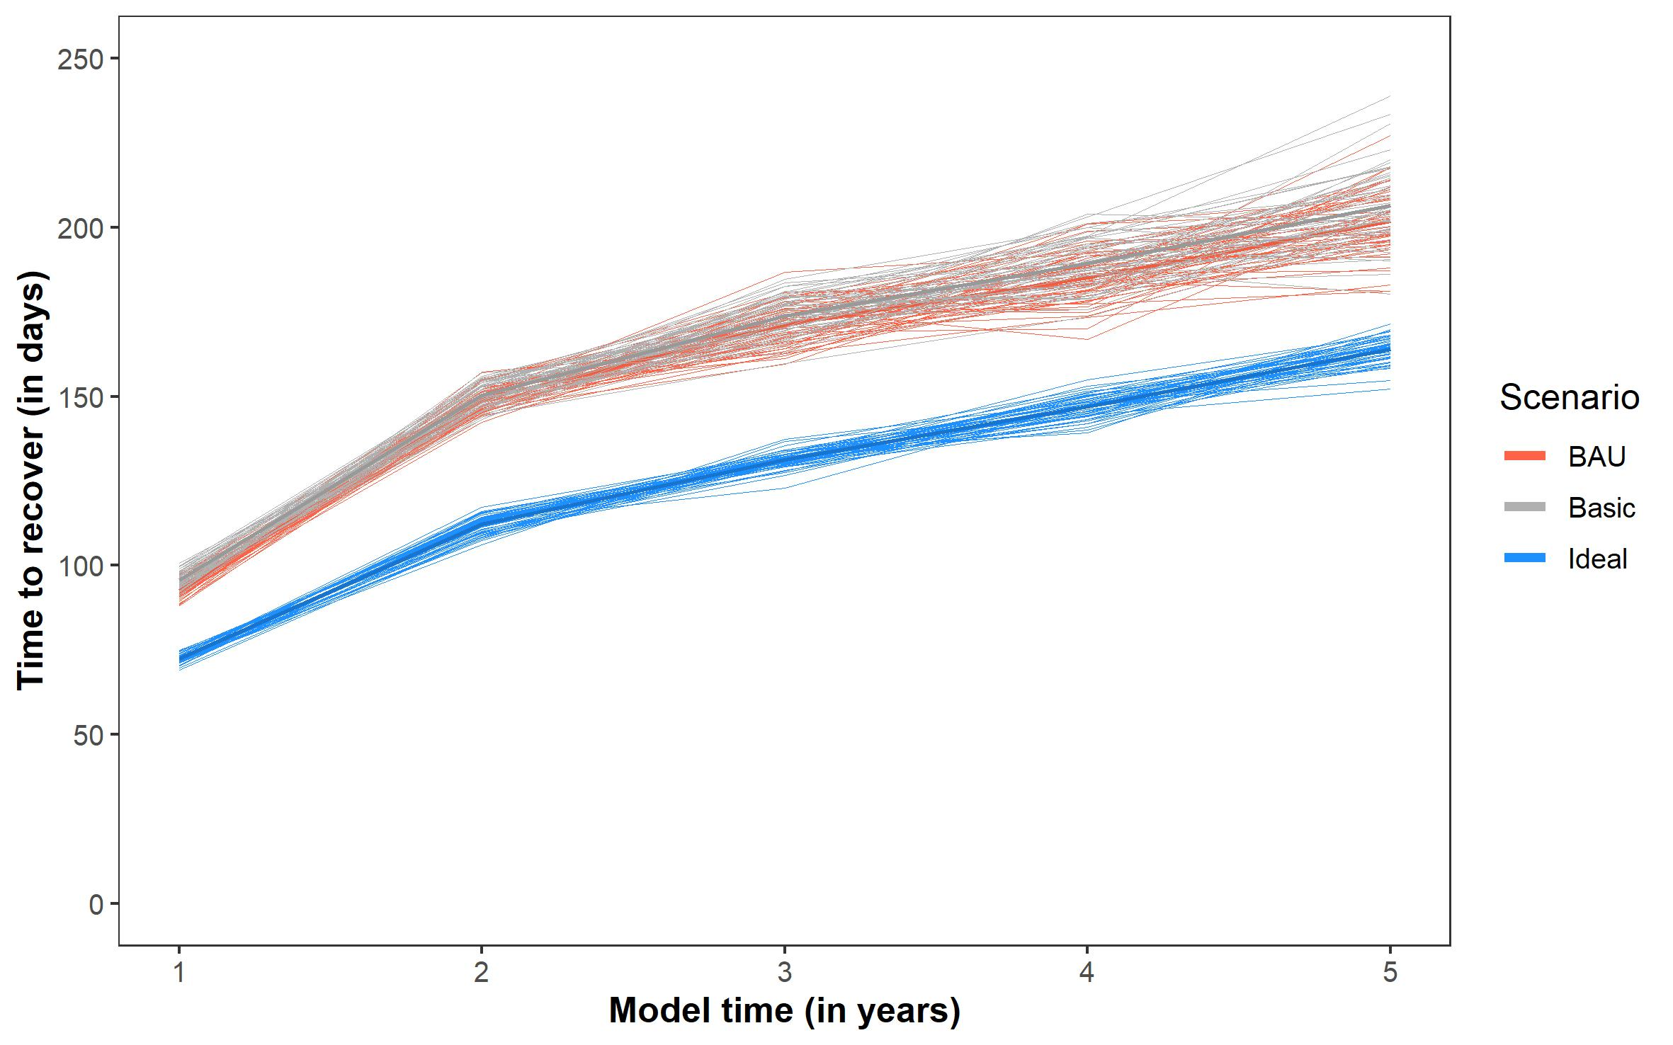

Figure 5. The length of time it takes for a young person to recover after engaging with care

Insight 3: Reduced wait times for psychology and multidisciplinary care.

Young people in the technology-enabled ‘circle of care’ typically waited for 60 days for psychology and other health professionals. This is a 60% reduction compared to BAU (150 days) and basic scenario (158 days).

The improvements made to being able to get young people to the right type of care faster (insight 1) and increasing the rate of recovery (insight 2), translates to improved throughput for the whole system. This means that the wait times for psychology and other health professionals is reduced since young people have their needs addressed sooner, which makes room for other young people to move off the waitlist and receive the care they need from the right health professional.

The ideal scenario includes more frequent and personalised monitoring and review of the waitlist and an individual’s needs (i.e., personalised and measurement-based care) which contributes to being able to efficiently add and remove young people to the right type of care. The type of technology infrastructure aims to help services provide more dynamic care that responds to the needs of the population, rather than being static and offering a ‘first in, first out’ service that does not aim to optimise the wait times for young people based on their individual needs.

The wait times for health professionals are still quite high under all three scenarios. This reflects the capacity constraints across the system, whereby the resources and types of care available in the system do not match the needs of the population. This type of mismatch results in longer wait times. So, the results here demonstrate the potential improvements that could be gained in the system if capacity across the services were maintained, however for further reductions in wait times, the combination of the technology-enabled ‘circle of care’ along with capacity increases are recommended.

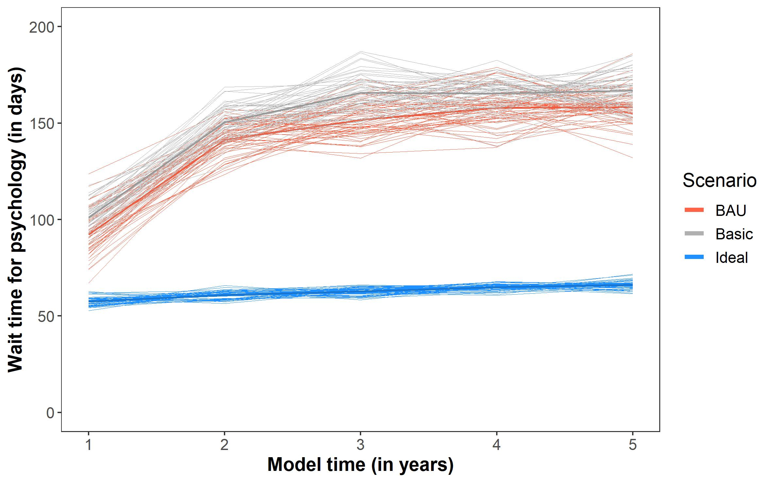

Figure 6. The time it takes to see a psychologist after being added to the waitlist for psychology.

Insight 4: Reduced rate of disengagement or discharge with unmet needs

About 42% of young people in the technology-enabled ‘circle of care’ disengaged or did not have their needs met over the course of care. This is a 30% reduction compared to BAU scenario (60%), and basic scenario (60%)

The improved throughput and service efficiencies across the system contribute to a reduced rate of disengagement from services. The reduced wait times for an intake assessment or to see a psychologist or other health professional (i.e., receive the right care plan) mean that the chance of disengaging from care is lower in the ideal scenario compared to BAU and basic scenarios. Furthermore, the ideal scenario also shifts the model of care to a focus on recovery rather than activity (or number of sessions) which means that young people are actively encouraged to stay engaged with services until their needs are met.

These rates of disengagement and discharged with unmet needs across all three scenarios are higher than would be expected in the real world. Further calibration will be required to refine these results, however without useful metrics about disengagement or how many young people are discharged with unmet needs, this is a useful start for testing the differences between the different scenarios.

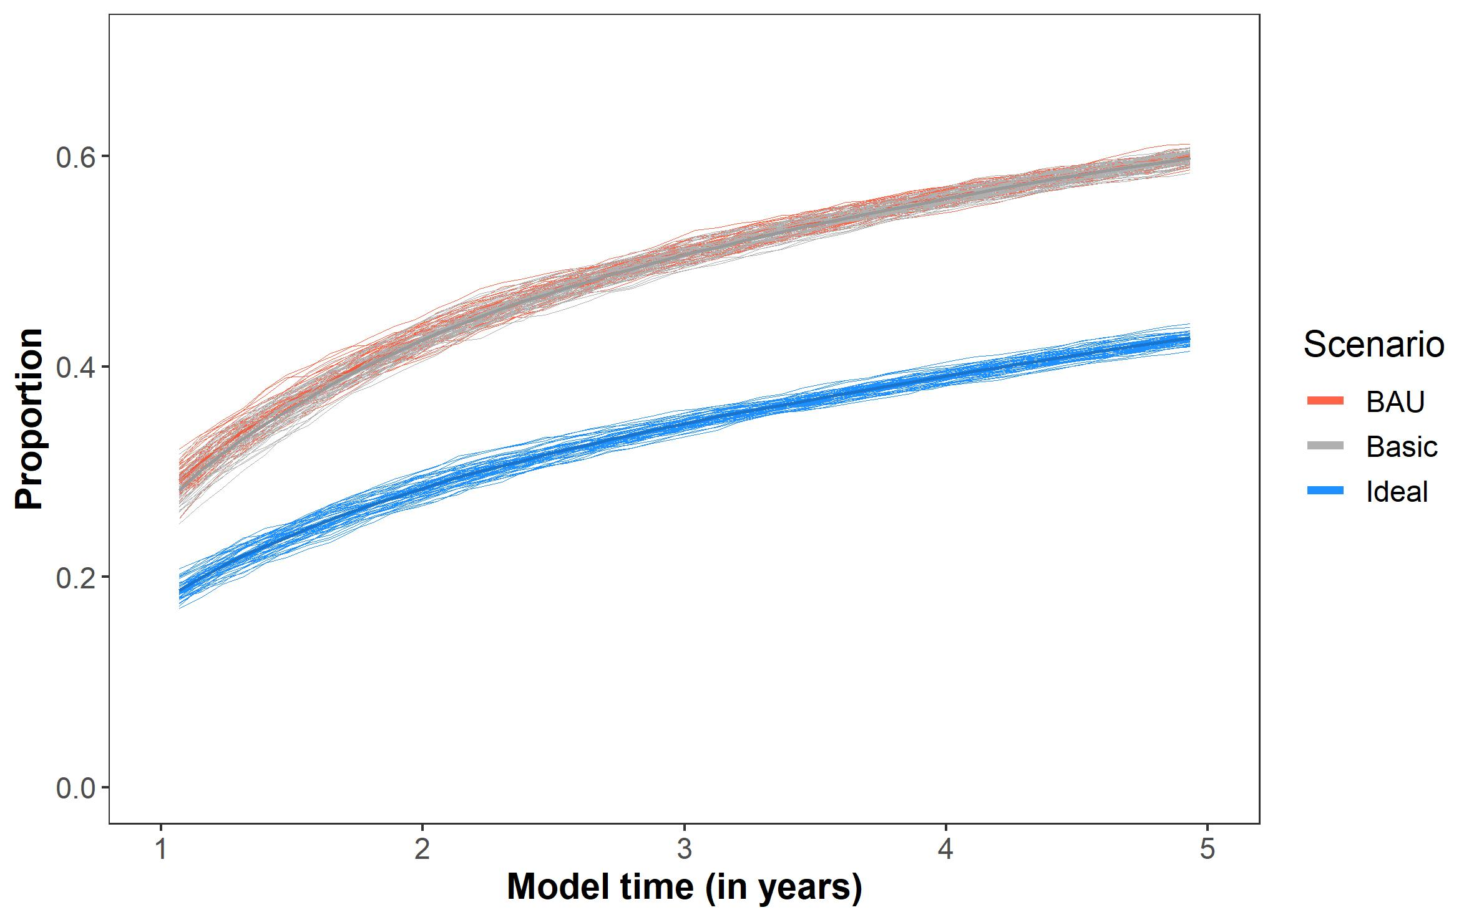

Figure 7. Overall proportion of people who disengage from care or discharged without having their needs met.

Concluding remarks
Its widely recognised that the future of mental health care is going to benefit from the use of digital technologies. Recent investments from the Australian government in the 2021 budget are a testament to their importance in the mental health landscape. Yet, careful consideration for how these technologies are implemented and used really matters if improvements to service efficiencies and clinical outcomes are to be achieved.

The work presented here shows that when digital technologies are rolled out or implemented into environment without changing the underlying model of care or existing service pathways within and between different services, then the impact is minimal or comparable to business as usual. Understanding this is critical because if new technologies are introduced yet do not yield improvements to service provisions, then this can lead to dissatisfaction from staff and clinicians which limits the widespread implementation, impact, and longevity of these solutions. To bring about real mental health reform we need to understand which components of digital technologies are required, what models of care and service pathways are needed to complement the use of these technologies and how does the workforce utilisation and training need to shift to accommodate and maximise these changes. Crucially, the funding schemes and cooperation of service providers, particularly across sectors and jurisdictions is vital to the success of a creating a person-centred youth mental health system.

The digital landscape is already a crowded space with different electronic medical record systems being used across a range of service providers, and new digital platforms and applications emerging rapidly, and so the danger is that we perpetuate the silos that already exist even further. Research regarding the effectiveness of digital technologies for mental health is growing, yet many of these innovations focus on the use of technologies within closed systems of care, often in isolation to other parts of the mental health system. This neglects that people typically need to access multiple parts of the system to receive effective care and that these needs a dynamic and often chronic. This works illustrates the benefits of a technology-enabled ‘circle of care’ which aims to break down the silos between services and improve the way service work together to provide more seamless and responsive pathways to care for young people. This involves a whole of system approach that challenges the traditional and often rigid health systems to ensure these tools are developed and integrated with services in a way that truly transforms clinical practice for the whole system.

While the work presented here provides some direction for the use of digital technologies in youth mental health care, the activities of this program extend beyond these findings and illustrate how smart health service infrastructures can be set up to provide services with real-time and dynamic insights about service efficiencies and the clinical outcomes of their service population. This infrastructure embeds dynamic simulation modelling into services to rapidly test the likely impacts of alternative strategies for resource capacity, allocation, scheduling, and other measures to improve operational efficiency and clinical outcomes.

References

Adair, C. E., McDougall, G. M., Mitton, C. R., Joyce, A. S., Wild, T. C., Gordon, A., . . . Beckie, A. (2005). Continuity of Care and Health Outcomes Among Persons With Severe Mental Illness. Psychiatric Services, 56(9), 1061-1069. doi:10.1176/appi.ps.56.9.1061
Australian Department of Health. (2017). The fifth national mental health and suicide prevention plan. Retrieved from Canberra:
Australian Institute of Health and Welfare. (2020). Deaths in Australia. Retrieved from Canberra: https://www.aihw.gov.au/reports/life-expectancy-death/deaths-in-australia
Australian Institute of Health and Welfare. (2021). Mental health services in Australia. Retrieved from https://www.aihw.gov.au/reports/mental-health-services/mental-health-services-in-australia:
Ben-Zeev, D. (2020). The digital mental health genie is out of the bottle. Psychiatric Services, 71(12), 1212-1213.
Brophy, L., Hodges, C., Halloran, K., Grigg, M., & Swift, M. (2014). Impact of care coordination on Australia's mental health service delivery system. Australian health review : a publication of the Australian Hospital Association, 38(4), 396-400. doi:10.1071/AH13181
Carlo, A. D., Barnett, B. S., & Unützer, J. (2020). Harnessing Collaborative Care to Meet Mental Health Demands in the Era of COVID-19. JAMA psychiatry.
Cross, S., Hermens, D., & Hickie, I. (2016). Treatment patterns and short‐term outcomes in an early intervention youth mental health service. Early Intervention in Psychiatry, 10(1), 88-97. doi:10.1111/eip.12191
Cross, S., Hermens, D. F., Scott, E. M., Ottavio, A., McGorry, P. D., & Hickie, I. B. (2014). A Clinical Staging Model for Early Intervention Youth Mental Health Services. Psychiatric Services, 65(7), 939-943. doi:10.1176/appi.ps.201300221
Davenport, T. A., Cheng, V. W. S., Iorfino, F., Hamilton, B., Castaldi, E., Burton, A., . . . Hickie, I. B. (2020). Flip the Clinic: A Digital Health Approach to Youth Mental Health Service Delivery During the COVID-19 Pandemic and Beyond. JMIR mental health, 7(12), e24578.
Davenport, T. A., LaMonica, H. M., Whittle, L., English, A., Iorfino, F., Cross, S., & Hickie, I. B. (2019). Validation of the InnoWell Platform: Protocol for a Clinical Trial. JMIR research protocols, 8(5), e13955-e13955. doi:10.2196/13955
Fletcher, S., Chondros, P., Palmer, V. J., Chatterton, M. L., Spittal, M. J., Mihalopoulos, C., . . . Gunn, J. (2019). Link-me: Protocol for a randomised controlled trial of a systematic approach to stepped mental health care in primary care. Contemp Clin Trials, 78, 63-75. doi:10.1016/j.cct.2018.12.014
Groom, G. (2003). 'Out of hospital, out of mind!' : a report detailing mental health services in Australia in 2002 and community priorities for national mental health policy for 2003-2008. Canberra: Mental Health Council of Australia.
Hickie, I. B., Scott, E. M., Cross, S. P., Iorfino, F., Davenport, T. A., Guastella, A. J., . . . Crouse, J. J. (2019). Right care, first time: a highly personalised and measurement‐based care model to manage youth mental health. Medical Journal of Australia, 211, S3-S46.
Hickie, I. B., Scott, E. M., Hermens, D. F., Naismith, S. L., Guastella, A. J., Kaur, M., . . . McGorry, P. D. (2013). Applying clinical staging to young people who present for mental health care. Early Interv Psychiatry, 7(1), 31-43. doi:10.1111/j.1751-7893.2012.00366.x
Isaacs, A., Beauchamp, A., Sutton, K., & Kocaali, N. (2019). Care Coordination Can Reduce Unmet Needs of Persons With Severe and Persistent Mental Illness. Front Psychiatry, 10, 563-563. doi:10.3389/fpsyt.2019.00563
Jones, E. B., & Ku, L. (2015). Sharing a Playbook: Integrated Care in Community Health Centers in the United States. American journal of public health, 105(10), 2028-2034. doi:10.2105/AJPH.2015.302710
Lambert, M. J., Harmon, C., Slade, K., Whipple, J. L., & Hawkins, E. J. (2005). Providing feedback to psychotherapists on their patients' progress: clinical results and practice suggestions. J Clin Psychol, 61(2), 165-174. doi:10.1002/jclp.20113
Lawrence, D., Hafekost, J., Johnson, S. E., Saw, S., Buckingham, W. J., Sawyer, M. G., . . . Zubrick, S. R. (2016). Key findings from the second Australian Child and Adolescent Survey of Mental Health and Wellbeing. Australian and New Zealand Journal of Psychiatry, 50(9), 876-886. doi:10.1177/0004867415617836
McGorry, P. D., Purcell, R., Hickie, I. B., Yung, A. R., Pantelis, C., & Jackson, H. J. (2007). Clinical staging: a heuristic model for psychiatry and youth mental health. Medical Journal of Australia, 187(S7), S40-S42. doi:10.5694/j.1326-5377.2007.tb01335.x
Mission Australia. (2017). Youth mentalhealth report: Youth Survey 2012-16.
National Mental Health Commission. (2014). The national review of mental health programmes and services. Retrieved from NMHC, Sydney:
Orygen. (April, 2019). Submission to the Productivity Commission’s Inquiry into Mental Health. Retrieved from
Patrick McGorry. (2021) Pat McGorry on the 'missing middle' of funding for mental health; and why things look good for post-COVID economic recovery/Interviewer: Tom Switzer. Between the Lines, ABC Radio National.
Paus, T., Keshavan, M., & Giedd, J. N. (2008). Why do many psychiatric disorders emerge during adolescence? Nature Reviews Neuroscience, 9(12), 947-957. doi:10.1038/nrn2513
Scott, J., Leboyer, M., Hickie, I., Berk, M., Kapczinski, F., Frank, E., . . . McGorry, P. (2013). Clinical staging in psychiatry: a cross-cutting model of diagnosis with heuristic and practical value. British Journal of Psychiatry, 202(4), 243-245. doi:10.1192/bjp.bp.112.110858
Shane P. M. Cross, B.Psych., M.Psych. ,, Daniel F. Hermens, Ph.D. ,, Elizabeth M. Scott, B.Sc., M.B.B.S. ,, Antonia Ottavio, Dip.Hth.Sc., B.Nursing ,, Patrick D. McGorry, M.D., Ph.D. , and, & Ian B. Hickie, M.D. (2014). A Clinical Staging Model for Early Intervention Youth Mental Health Services. Psychiatric Services, 65(7), 939-943. doi:10.1176/appi.ps.201300221
Sherman, M., Barnum, D., Buhman-Wiggs, A., & Nyberg, E. (2008). Clinical Intake of Child and Adolescent Consumers in a Rural Community Mental Health Center: Does Wait-time Predict Attendance? Community Mental Health Journal, 45, 78-84.
Shimokawa, K., Lambert, M. J., & Smart, D. W. (2010). Enhancing treatment outcome of patients at risk of treatment failure: meta-analytic and mega-analytic review of a psychotherapy quality assurance system. Journal of consulting and clinical psychology, 78(3), 298.
Tam, H., & Ronan, K. (2017). The application of a feedback-informed approach in psychological service with youth: Systematic review and meta-analysis. Clinical Psychology Review, 55, 41-55.
Westin, A. M., Barksdale, C. L., & Stephan, S. H. (2014). The effect of waiting time on youth engagement to evidence based treatments. Community Ment Health J, 50(2), 221-228. doi:10.1007/s10597-012-9585-z

Acknowledgements
Thank you to the Bupa Foundation for generously supporting this work and thank you to the health services, clinicians, and young people who have participated in this research to date and continue to engage with us for the project. Title page image by @Thiszun, via Pexels.com

Appendix A – Codesign work

Table 1. Co-design and service mapping workshops with stakeholders from each service

 | Workshop 1 | Workshop 2 | Workshop 3
Participants | Young people, supportive others, health professionals, service managers, service administrators | Health professionals, service managers, service administrators | Health professionals, service managers, service administrators
Workshop content | - Current service pathway  - Information flows  - Communication and coordination of care (within and between services) | - Key service provisions (availability, accessibility, service gaps, coordination processes)  - Barriers/facilitators regarding implementation of a HIT  - Appropriate clinical content of a HIT | - Key service provisions (availability, accessibility, service gaps, coordination processes)  - Barriers/facilitators regarding implementation of a HIT  - Appropriate clinical content of a HIT
Workshop outcome | - An example user journey within a service, and between services  - Qualitative data for knowledge translation | - Qualitative data for knowledge translation | - Qualitative data for knowledge translation

Common problems across settings
- Mental health treatment isolated from other physical/ social needs
- Late intervention
- Lack of communication between services
- Inefficient resource allocation
- Low service capacity/under resourced
- Long wait times for services (esp. psychology)
- High costs limits pathways/option
- Unable to deal with complex issues
- Poor access to psychology and psychiatry
- Duplication of information and technology systems (redundancies)
- Lack of cooperation between funders and service providers

Appendix B - Model description
Sample characteristics
This model has been developed using a longitudinal database developed by the Brain and Mind Centre of approximately 3,000 young people between 12-25 years old since 2008. At the start of the simulation a population of 15,000 agents is initialised with different clinical needs (Figure 1, panel A). Conditional distributions for age and Social and Occupational Functional Assessment Scale (SOFAS) were based on clinical stage for population characteristics drawn from this cohort, which represents young people who typically present for mental health care across the participating services (Figure 1, panel B and C). Other clinical characteristics were conditional on clinical needs (table 2).

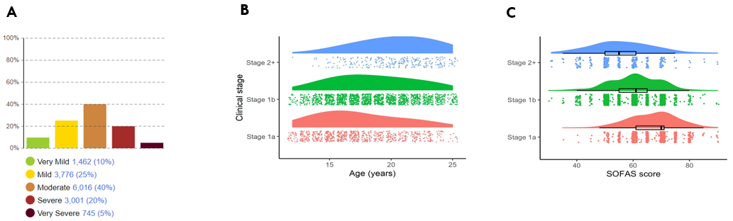

Figure 1. Sampling distributions for initialising the population for the simulation model. Panel
A shows the distribution of clinical needs in the population of agents. Panel B shows the conditional distribution of age based on clinical stage. Panel C shows the conditional distribution of SOFAS score (functioning) based on clinical stage.

Table 2. Conditional distributions based on clinical needs.
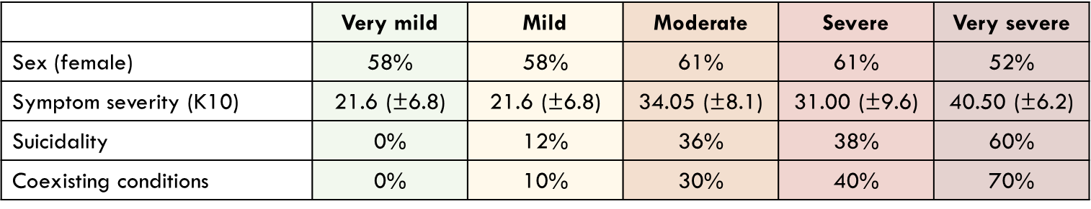

Agent structure and assumptions – Person

The state chart presented in figure 2, illustrates the different possible states a young person can be in. These states determine the probability the agent will engage in treatment seeking behaviour and the effectiveness of treatment. All agents start in the ‘notHelpSeeking’ state whereby they will not be interacting with services or receiving treatment. Agents in this state will decide whether to present for care based on a probability that reflects real world treatment seeking rates, which is when they will move to the ‘helpSeeking’ state. While in this state, agents will present to one of the health services included in the model and proceed along a service pathway (see next few pages). The longer agents spend in this help seeking state the higher the probability that the will disengage from care and proceed to the ‘disengaged’ state. Otherwise, once an agent has completed intake and received a care plan from a service, they will proceed to the ‘hasCarePlan’ composite state. If the care plan is right (figure 3) they will enter the ‘right’ state, if the care plan is not right, they will enter the ‘notRight’ state. While in the ‘notRight’ state, treatment effectiveness is reduced by ~50%. While in the ‘hasCarePlan’ composite state, agents will present for treatment at a rate determined by their care plan (see care planning section, page 25-27), until they either recover or disengage (see page 26 for model logic).

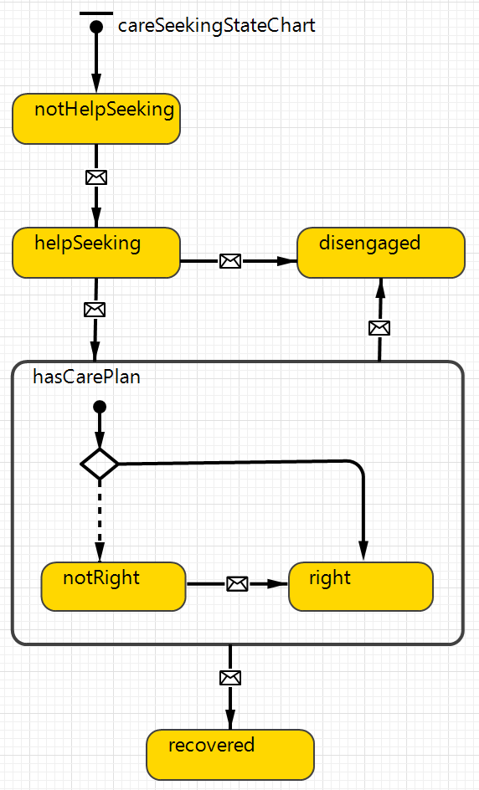
Figure 2. Care seeking state chart which governs agent behaviour for engaging with care

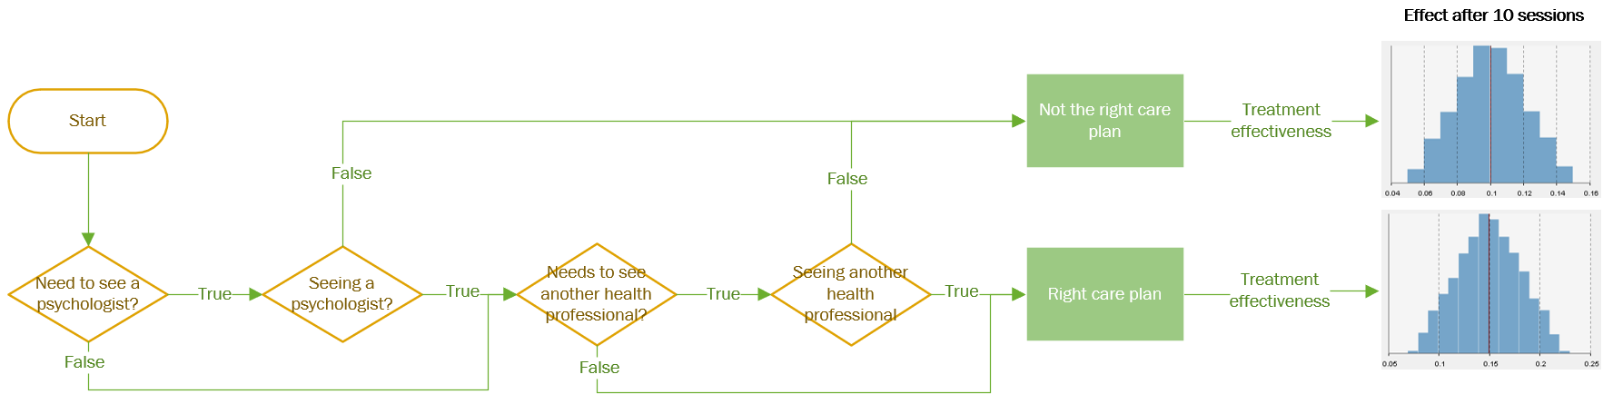
Figure 3. Model logic for evaluating whether someone is on the ‘right’ care plan

Agent structure and assumptions – Initial contact with service
Business as usual | Basic implementation | Ideal implementation (‘circle of care’)
Additional clinician time is needed to arrange other services (e.g. phone calls, online admin) for those who are ineligible. High duplication technologies and poor interoperability (~4-5 technologies)  No standardised entry to circle of care | Additional clinician time is needed to arrange other services (e.g. phone calls, online admin) for those who are ineligible. High duplication technologies and poor interoperability (~4-5 technologies, role switching)  No standardised entry to circle of care means ineligible agents are referred to other services | Enter ‘circle of care’ via technology pathway to find right service. Low duplication of systems and increased interoperability (~2-3 technologies) means initial referral time is reduced by ~50%).  Standardised entry to circle of care means all agents are eligible and they will be guided to right service.

Figure 4. Discrete event process for agents presenting for care

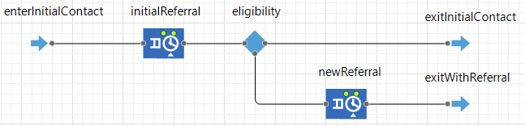

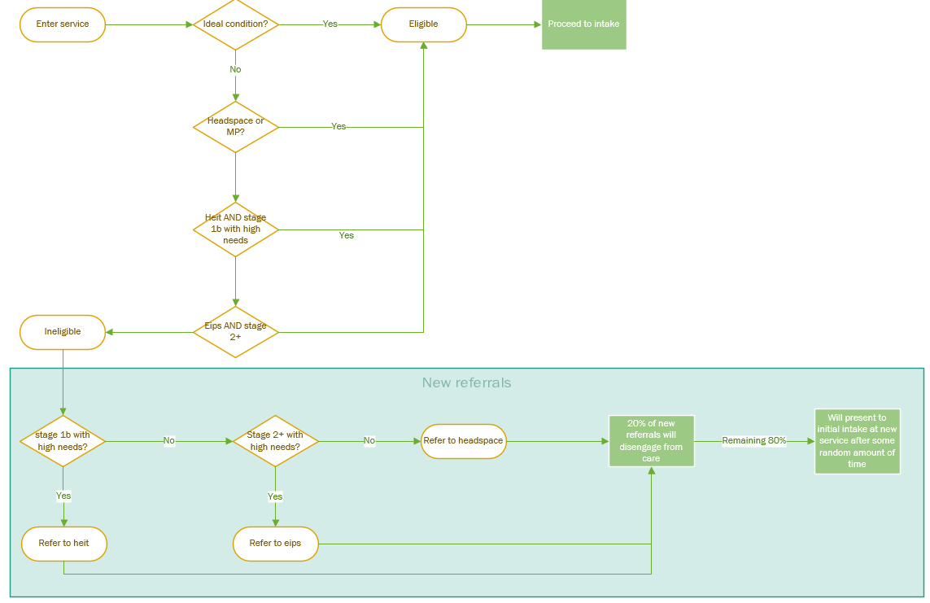
Figure 5. Model logic for determining whether an agent is eligible for the service

Agent structure and assumptions – Intake process
Business as usual | Basic implementation | Ideal implementation (‘circle of care’)
Intake assessments are conducted face-to-face by a clinician. This means there is a wait time between service entry and first assessment of need (face-to-face bottleneck).  Waiting too long for intake assessment will lead to disengagement. | The young person proceeds straight from initial contact to an online assessment (i.e. ‘no wait list’). All young people proceed to intake session before case review to complete intake (i.e. for engagement).  Waiting too long for intake assessment will lead to disengagement. | The young person proceeds straight from initial contact to an online assessment (i.e. ‘no wait list’). Young people with very mild clinical needs (i.e. stage 1a, no suicidality, good functioning, no coexisting conditions) are immediately assigned an online care plan. Young people with very severe clinical needs are seen by a psychologist who determine best care plan/service. All remaining young people proceed to care planning.  Waiting too long for initial coordination will lead to disengagement.

Figure 6. Discrete event process for agents completing intake process
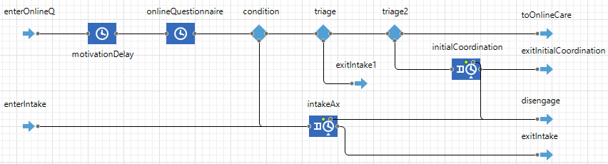

Agent structure and assumptions – Care planning
Business as usual | Basic implementation | Ideal implementation (‘circle of care’)
New cases are reviewed at a daily 1-hr team meeting  Coordination with other services/providers is inconsistent and requires additional clinician time to arrange other services (e.g. phone calls, online admin).  Young person enters new service at intake. | New cases are reviewed at a daily 1-hr team meeting  Coordination with other services/providers is inconsistent and requires additional clinician time to arrange other services (e.g. phone calls, online admin).  Young person enters new service at intake. | New cases are reviewed by highly skilled/senior clinician  Shared and interoperable technology for care plans and transfer of young people to new services/providers. (coordination time is reduced by ~50%).  Young people enter new service at care allocation (i.e. continuity of care).

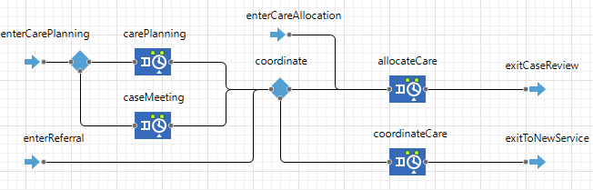
Figure 7. Discrete event process for agents entering care planning. Intake is complete once a care plan has been assigned and the agent exits this process.

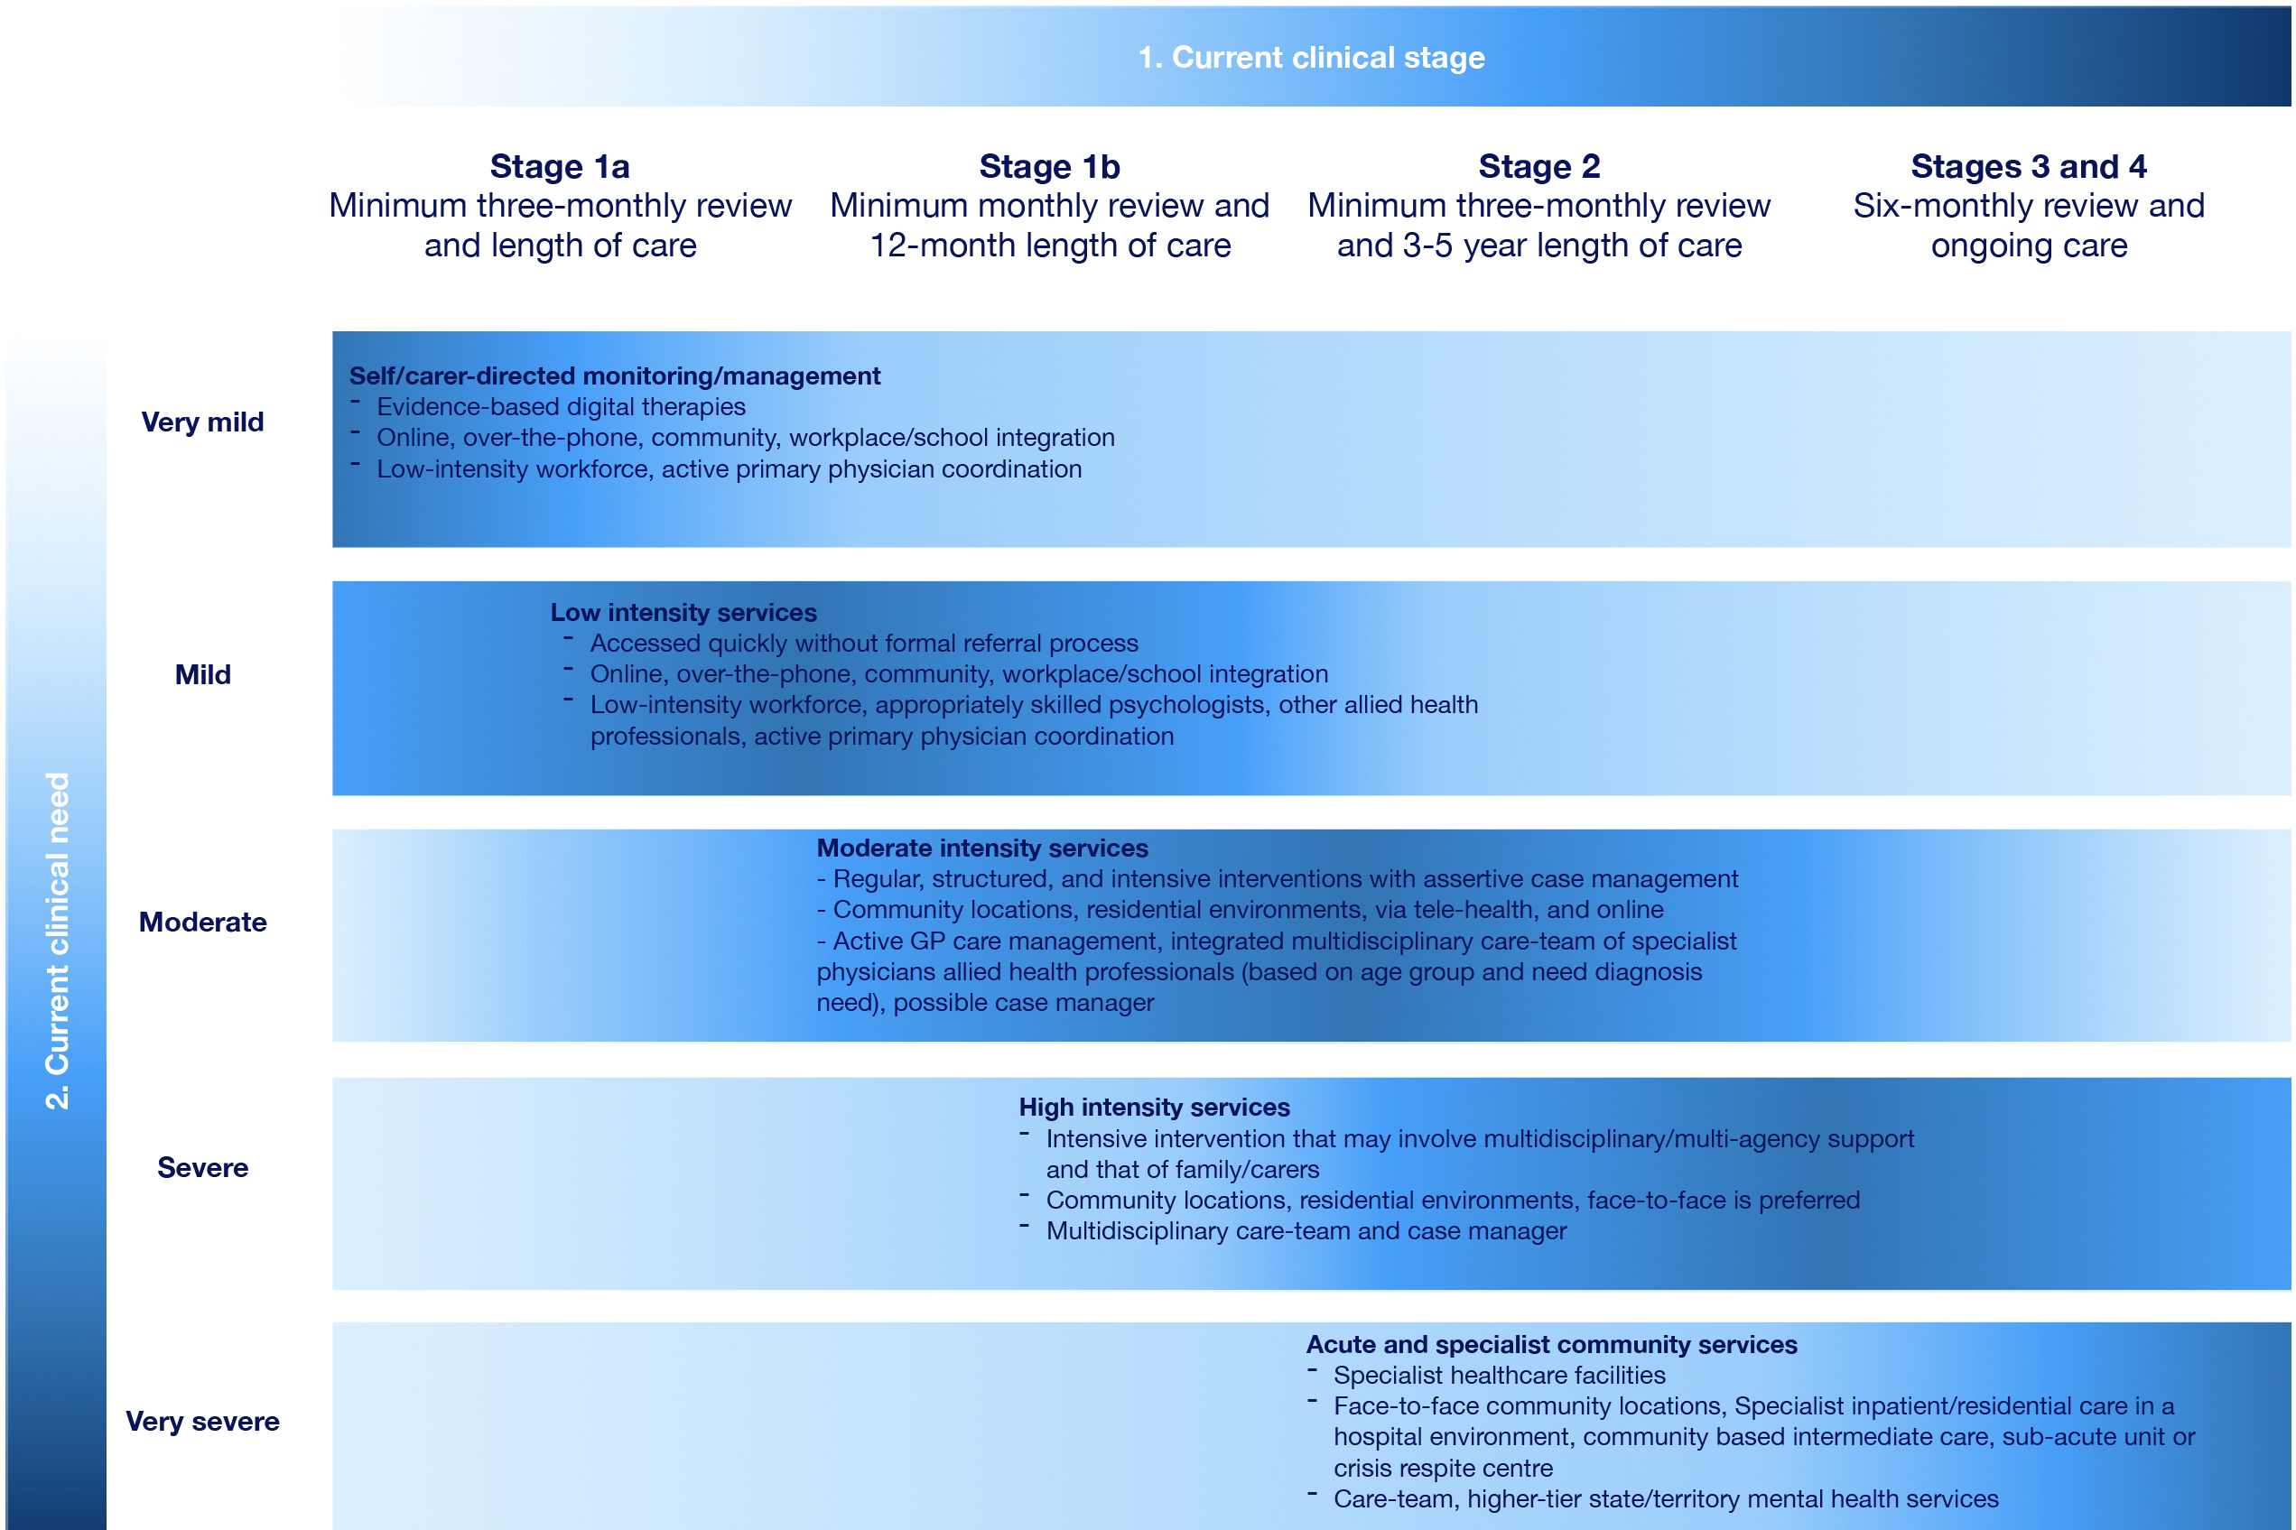
Figure 8. Guidelines for making personalised care decisions based on the BMC youth model
Figure 9. Model logic for determining the right treatment plan for the agent. The treatment plan includes parameters which controls the frequency by which the agent presents for treatment, the frequency the agent has their care plan reviewed, whether the agent needs to see a psychologist and whether the agent needs to see another health professional (medical or allied). The only difference between scenarios here is that the treatment frequency and review is personalised to the agent in the ideal scenario. Determining the need for psychologist or other health professional does not differ among each scenario.
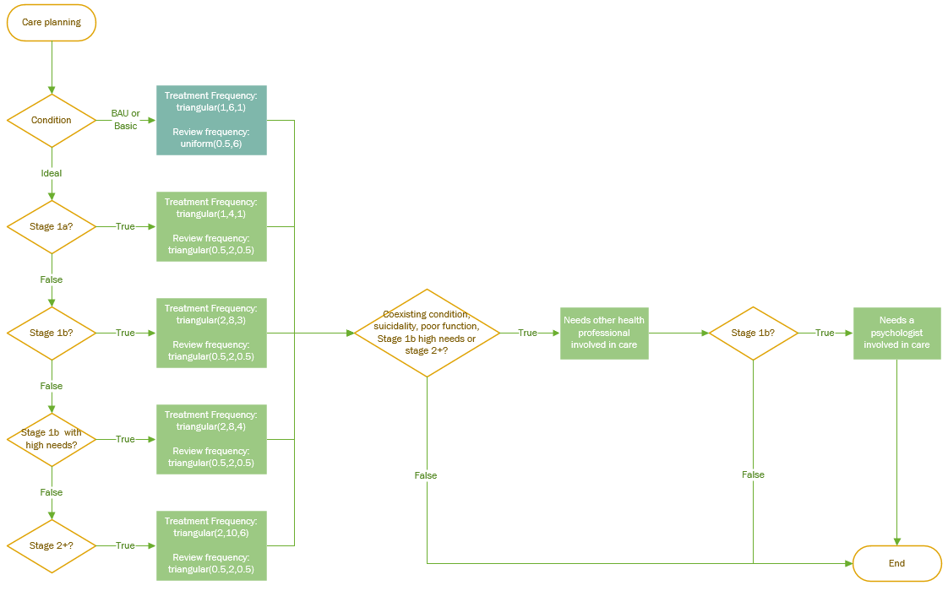

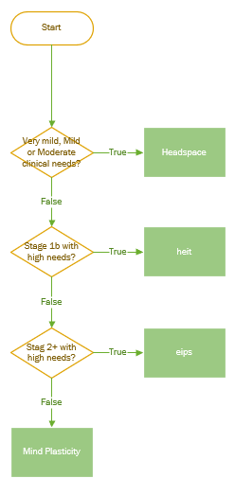
Figure 10. Model logic for determining which service environment is right for the agent. This logic is consistent across all scenarios. This is a conservative assumption that favours BAU and Basic scenarios because determining the right service based on clinical staging and needs does not occur this consistently.
Agent structure and assumptions – Treatment

Business as usual | Basic implementation | Ideal implementation (‘circle of care’)
Treatment frequency and progress reviews are unconditional  Young people will disengage due to reaching if they reach their max sessions (20), or 10% will disengage if after 10 sessions they still don’t have the right care plan. | Treatment frequency and progress reviews are unconditional  Young people will disengage due to reaching their max sessions (20), or 10% will disengage if after 10 sessions they still don’t have the right care plan. | Treatment frequency and progress reviews are conditional on stage and need (BMC youth model figure)  10% will disengage if after 10 sessions they still don’t have the right care plan.

Treatment effectiveness
Model logic for determining right care plan involves determining whether an agents care plan matches their severity clinical needs. The severity of their clinical needs determines (a) what the right service environment is; (b) whether they need psychology; and (c) whether they need another health professional (medical of allied). If all these needs are met then the care plan is deemed to be ‘right’. Table 3 presents the difference in effect sizes based on ‘right’ or ‘not right’ care plans.

Table 3. Treatment effectiveness value represents potential effect after 10 sessions.

Treatment effectiveness | Care plan
0.15 (0 – 0.225) | RIGHT
0.075 (0 – 0.15) | NOT RIGHT

Recovery
Recovery is defined as 3 consecutive sessions with a SOFAS score greater than 70 (non-clinical cut off). We have employed this is a simplistic implementation of ‘recovery’ for this initial proof of concept version of the model. Future versions of this model will expand the definition of recovery to be more person-centred, and incorporate definitions based on lived experience feedback through further consultations and workshops to be held in 2021.

Monitoring and case review
Agents will present for review at a rate determined by their care plan (Figure 11). When presenting for review, their care plan/needs and their current care allocation will be assessed to determine if a change needs to occur. The change decisions will involve allocating a psychologist or other health professional to the agents care if it is required and available or adding them to the waitlist for this type of treatment if it is required and unavailable.

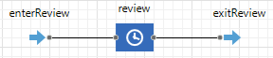
Figure 11. Discrete event process for case review. This does not currently utilise any service resources because this is a simplified version of the model. In later iterations service resources will be used to carry out this process.
Calibration results – Demand for services

The demand for services which is defined as the number of new people presenting per week is an important component of this model. So ensuring that the model reproduces current and historic patterns of demand is vital. Figure 12 below demonstrates that not only is the rate of demand consistent across all scenarios, but the demand rate reproduces the average rates reported to use by each service during the consultation work. The values provided to us by each service were: 25 to 30 for headspace, 10 to 15 for Min Plasticity, 4 to 8 for hEIT, and 5 to 8 for EIPS.

Figure 12. Demand for services calibrated to the reported presentation rates for each service

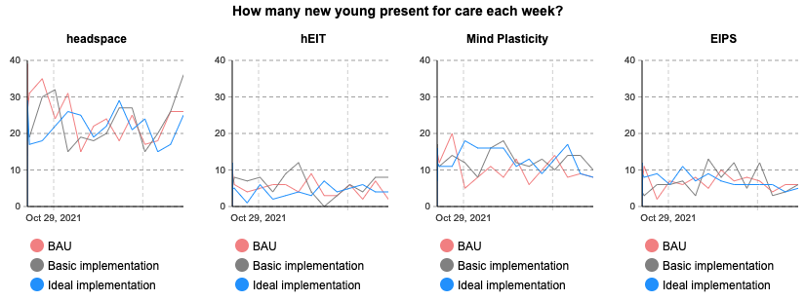

Appendix C – Implementation work
The impact of implementing the InnoWell Platform into participating services will be evaluated through our health service implementation research. Quantitative and qualitative data will be collected from service staff (health professionals, managers, and administrative staff), via online surveys, semi-structured interviews, group workshops, and research officer logs. Table 4 displays an overview of the data collected for the health service implementation research. This data will be collated into a report to facilitate the ongoing co-design and improvement of the InnoWell Platform.

Table 4. An overview of the data collected for health service implementation research

 | Online survey | Semi-structured interview | Implementation log | Service audit
Frequency | Three-monthly | Three-monthly | Monthly | Three-monthly
Evaluation outcome collected | Adoption of digital health solution | Impact of digital health solution on service | Impact of digital health solution on service | Client safety
 | Staff views on digital health | Quality, acceptability, usability of the digital health solution | Quality, acceptability, usability of the digital health solution | Client accessibility and equity
 | Education and training outcomes | Education and training outcomes | Education and training outcomes | Workforce (staff numbers, FTE)
 |  | Digital readiness and staff competence | Implementation barriers and facilitators | Service efficiency, expenditure, and cost
 |  |  |  | Service effectiveness and outcomes
 |  |  |  | Service continuity and coordination

