EPIC-START Newsletter

Overview
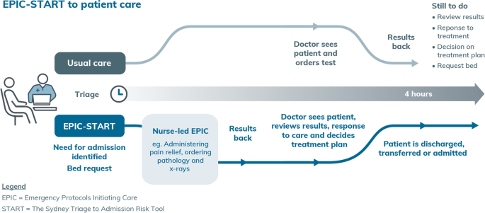
EPIC-START is a 5-year project (“Implementation evaluation of the Emergency nurse Protocol Initiating Care—Sydney Triage to Admission Risk Tool (EPIC-START) model of care”) supported by the Medical Research Future Fund. EPIC-START aims to decrease Emergency Department (ED) length of stay and improve patient safety and experience through earlier decision-making, delivery of care and detection of clinical deterioration by implementing the Agency for Clinical Innovation’s (ACI) ECATs with START using a data driven and clinician behaviour change informed implementation strategy.

Emergency Care Assessment and Treatment (ECAT) protocols
ECATs (previously EPICs) are 73 adult and paediatric protocols for nurses to initiate care for some of the most common ED presentations, accessible via the ACI website Emergency care assessment and treatment. Nurses are responsible for knowing their scope of practice prior to activating treatment. There are two compulsory modules in My Health Learning: Nursing in Emergency Settings and ECAT – and introduction to protocols. It is the responsibility of the LHDs to ensure nurses complete the required steps to ensure recognition of prior learning in line with the ACI/NSW Health Education and Recognition of Prior Learning guide.

Sydney Triage to Admission Risk Tool (START)
The START, Modified Early Warning Score (MEWS) and Paediatric Early Warning Score (PEWS) algorithms are in development with the Health Systems Support Group which will be imbedded into the patient flow portal for use. The delivery of these systems for User Acceptability Testing is scheduled for April 2024. Finalisation of these tools is expected to align with the NSW ACI ECAT Go Live dates in June 2024. The EPIC-START CNCs have been updated with a list of considerations to prepare their research sites for implementation.
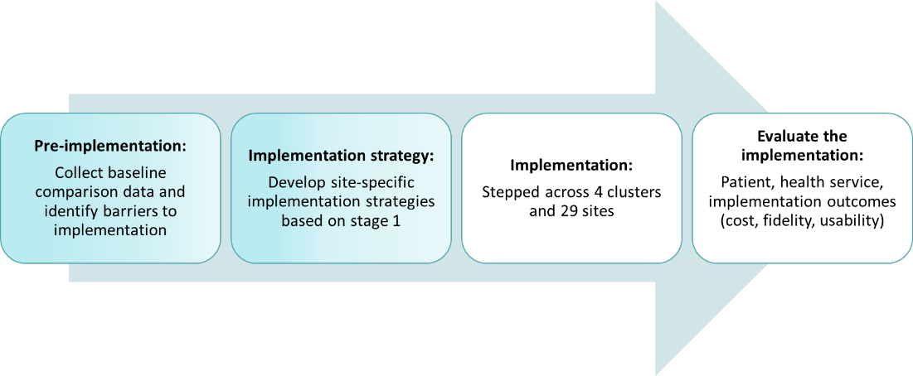
Overall phases of the study, shading shows progress

Ethics
EPIC-START was approved by Sydney Local Health District Human Research Ethics Committee in October 2022. (2022/ETH01940) and site-specific approval obtained for all sites Australian and New Zealand Clinical trial, ACTRN12622001480774p. Registered on 27 October 2022.

EPIC-START UPDATES

Phase 1: Pre-implementation update
Pre-implementation has commenced at all study sites. Nursing and medical staff were surveyed about their perspectives on nurse-initiated care and their workplace environment to identify barriers and facilitators to implementation of the EPIC-START model of care and inform the implementation.
More than 360 nurses completed the survey and indicated they like nurse-initiated care because it improves patient care and speeds things up for their patients. They reported the previous protocols were too limited, difficult to access and vague. Nurses stated they needed more confidence in some of the more complex nurse-initiated care such as x-ray ordering and paediatric medications. They also advised the things most helpful to use the protocols would be face to face education (94.2%), support in the clinical environment (94.5%), time to attend learning (94%) and a structured education program (93%). Doctors were also surveyed and overwhelmingly supported nurse-initiated care, but with robust face-to-face education and clinical support.

Education program
As part of the pre-implementation process, an EPIC-START Education program was developed by expert clinicians, academics and educators with 367 years of combined emergency nursing experience and considering the survey findings. The program adheres to NSW Health policy directive, The Use of the Emergency Care Assessment and Treatment (ECAT) Protocols (PD2024_011). As part of development, the more than 70 embedded policies comprising 2420 pages were reviewed and considered.
The program is grounded in best-practice pedagogy, scaffolded to support deep learning and embed knowledge in long term memory. The EPIC-START education program is structured with principles of safety and quality, targeting thorough patient assessment using the evidence based HIRAID® emergency nursing framework, identifying risk factors for adverse outcomes, recognising and responding to clinical deterioration, cognitive bias, critical thinking and reducing cognitive load. The EPIC-START program respects and responds to emergency nurses’ needs and empowers them to deliver safe evidence-based care. Nurses from the 4 study EDs said they needed structured face-to-face education, support on the floor and protected training time for them to feel safe to use ECATs.
The EPIC-START Education Program comprises three courses:
- EPIC-START INSTRUCTOR. One-day for senior nurses to teach the EPIC-START CIN and CREDIT courses. Nine Instructor courses with 110 senior nurses have been held to date to enable implementation fidelity.
- EPIC-START CIN Course. Two-days for nurses who have completed a Transition to Speciality Emergency Practice Program (or equivalent) and/or the Nurse Delegated Emergency Care Course.
- EPIC-START CREDIT. One-day for nurses who have completed a Clinical Initiatives Nurse Program (CIN) or First Line Emergency Care Course (FLECC), including nurse-initiated x-rays.
Study Site | EPIC-START CNC | Milestones | Go live
Southern NSW | Dot Hughes  Donna Skelly | - Staff surveys complete, patient surveys underway  - Instructor courses completed 19th April  - CREDIT/CIN Courses commenced 19th April | 25 June 2024
Sydney LHD | Rebecca Richardson | - Staff surveys complete, patient surveys underway  - Instructor courses complete 22nd February  - CREDIT/CIN Courses commenced 5th March | 18 June 2024
Northern NSW | Suskia Travis | - Staff surveys complete, patient surveys underway  - Instructor course is complete  - CREDIT/CIN Courses commenced 25th March | 25 June 2024
WSLHD | Danielle Parrett | - Staff and patient surveys started in April  - Instructor course complete 23rd April  - CREDIT/CIN Courses commencing 12th May | 17 July 2024

Publications
- Berendsen Russell, S., Seimon, R., Dixon, E. et al. Applying Sydney Triage to Admission Risk Tool (START) to improve patient flow in emergency departments: a multicentre randomised, implementation study. BMC Emerg Med 24, 39 (2024). https://doi.org/10.1186/s12873-024-00956-5
This paper presents the effectiveness of applying the Sydney Triage to Admission Risk Tool (START) in conjunction with senior early assessment in different Emergency Departments (EDs). The findings were “… START, when used in conjunction with senior early assessment was associated with some reduced ED length of stay.”
- Curtis, K., Murphy, M., Kourouche, S., Hughes, D., Casey, L., Gawthorne, J., Berendsen-Russell, S., Couttie, T., Skelly, D., Williams, N., Shaban, R. Z., Fry, M., Kloger, R., Rheinberger, J., Aggar, C., & Considine, J. (2024). Designing a standardised emergency nurse career pathway for rural, regional and metropolitan contexts: A consensus process. Australasian Emergency Care, https://doi.org/10.1016/j.auec.2024.03.002
A consensus process used to develop the emergency nurse career pathway to embed EPIC-START education is reported in this paper. “A standardised career pathway with minimum 180 hours would enable a consistent approach to emergency nursing training and enable nurses to work to their full scope of practice. This will facilitate transferability of emergency nursing skills across jurisdictions.”
- Curtis, K., Dinh, M.M., Shetty, A. et al. The Emergency nurse Protocols Initiating Care—Sydney Triage to Admission Risk Tool (EPIC-START) trial: protocol for a stepped wedge implementation trial. Implement Sci Comms 4, 70 (2023). https://doi.org/10.1186/s43058-023-00452-0
The study protocol was published in June 2023 that presents the methodology proposed to evaluate the EPIC-START model of care. “This study protocol adopts an effectiveness-implementation hybrid design and uses a stepped–wedge cluster randomised control trial of EPIC-START, including uptake and sustainability, within 30 EDs across four NSW local health districts spanning rural, regional, and metropolitan settings.”

Investigators and partners
Professor Kate Curtis (lead) | University of Sydney and Illawarra Shoalhaven LHD
Dr Sarah Kourouche (project manager) | University of Sydney
Professor Michael Dinh | Sydney Local Health District, Greenlight Institute, The University of Sydney
Dr Amith Shetty | Western Sydney Local Health District, Ministry of Health
Professor Margaret Fry | University of Technology Sydney, Northern Sydney LHD
Professor Timothy Shaw | University of Sydney
Dr Thomas Lung | University of Sydney
Associate Professor Margaret Murphy | Western Sydney Local Health District, The University of Sydney
Associate Professor Ling Li | Macquarie University
Dr Hatem Alkhouri | University of NSW
Professor Julie Considine | Deakin University and Eastern Health, VIC
Dr James Hughes | Queensland University of Technology
Professor Ramon Shaban | University of Sydney, Western Sydney LHD,
Dr Wayne Varndell | College of Emergency Nursing Australasia (CENA), UTS Sydney
Associate Professor Christina Aggar | Northern NSW Local Health District, Southern Cross University
Adj Prof Alfa D’Amato | Ministry of Health
Mrs Saartje Berendsen Russell | Sydney Local Health District, Green Light Institute
Dr Trevor Chan | Australian College for Emergency Medicine
Prof Julia Morphet | College of Emergency Nursing Australasia (CENA), Monash University
Ms Margherita Murgo | Australian Commission on Safety and Quality in Healthcare
Prof Judy Mullan | University of Wollongong
Ms Kerrianne Ryan | NSW eHealth
Dr Radhika Seimon | Sydney Local Health District, Green Light Institute
Dr Mary Lam | Royal Melbourne Institute of Technology, University of Sydney
Ms Louise Casey | Southern NSW Local Health District, University of Sydney

