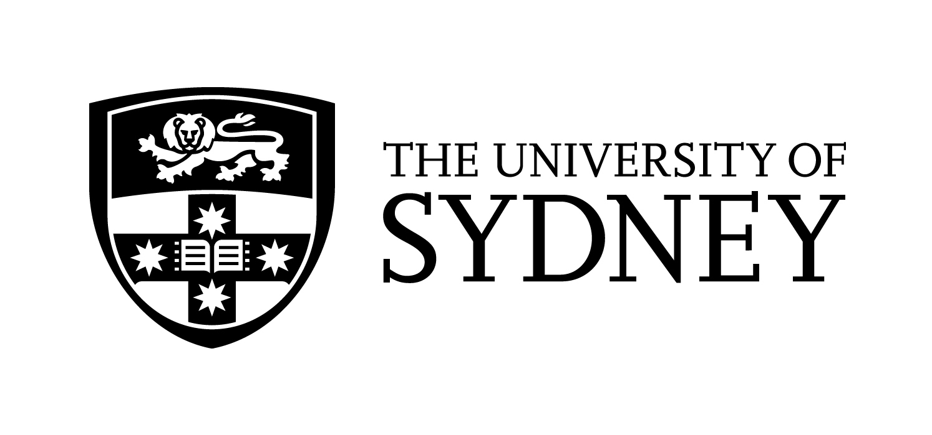

The Sovereign Ghost: Antonio Caldara and the Eclipses of Cultural History
Professor Harry White (University College Dublin)

Sydney Conservatorium of Music

Abstract

The Venetian composer Antonio Caldara (1670-1736) has endured an afterlife of almost total eclipse. Despite an immense catalogue (estimated at over three thousand works) and twenty years’ distinguished service at the court of Charles VI, Caldara has languished in the shadow of his close contemporary and fellow Kapellmeister in Vienna, Johann Joseph Fux (c. 1660-1741). It remains legitimate to add, however, that both composers have received far less than their due in the annals of reception history, to say little of contemporary performance and circulation. In this lecture, I propose an explanation for this state of affairs which draws upon my recent monograph, The Musical Discourse of Servitude (Oxford University Press, 2020), in order to identify Caldara as a crucial agent in the development of a work-based autonomy, through which eighteenth-century music became emancipated from the servitude of liturgical practice. I shall also countenance the difficulties of rehabilitating Caldara’s prodigious musical estate at the present moment, when the very concept of European music (and within that fold, the legitimacy of ‘the composer’ as an abiding entity) is under siege. I shall (lastly) argue that a genre-based history of European music in the early eighteenth century, in contradistinction to our contemporary preoccupation with Bach and Handel in particular, is likely to throw Caldara’s significance into much sharper relief than has hitherto been the case.

Contact

Alan Maddox
Senior Lecturer in Musicology
Sydney Conservatorium of Music

Room 2079 Sydney Conservatorium of Music (C41)
Macquarie Street, Sydney 2000

alan.maddox@sydney.edu.au

CRICOS 00026A

